Remote Access VPN (Global Protect), IP/IDS Utilizing SNORT

Yogaraj Govindarajalu Prabagaran

# Table of Contents

Table of Contents 2

Lab 4- Remote Access VPN (Global Protect) 3

Part 1- Building the initial Topology. 3

Description 3

Preparation 3

Observations 3

Screenshots 4

Reflection 8

Part 2- Configure Global Protect to allow remote access to your users: 9

Description 9

Preparation 9

Observations 9

Screenshots 10

Reflection 16

Lab 5- Monitoring Network Traffic (IP/IDS) 16

Part 1- Installation of the packages and SNORT 16

Description 16

Preparation 16

Observations 17

Screenshots 17

Reflection 21

Part 2- Configuring SNORT for IDS 21

Description 21

Preparation 22

Observations 22

Screenshots 22

Reflection 37

References 38

# Lab 4- Remote Access VPN (Global Protect)

# Part 1- Building the initial Topology.

## Description

The main goal of Part 1 of the lab is to establish and validate the initial network topology. This involves configuring all network components according to the provided topology, ensuring access to the webserver from the trusted zone, validating the digital certificate on the firewall signed by the CA server, enabling ICMP on all interfaces for troubleshooting, and confirming access to the internet interface of the firewall from the outside untrusted zone. Once these steps are completed successfully, the lab proceeds to Part 2, where further configuration of the firewall for global Protect.

## Observations

Connectivity and Functionality: I observed the successful establishment of connectivity and functionality among the network components.

Digital Certificate Validation: I noted the successful validation of the digital certificate on the firewall. This ensured secure communication within the network and validated the authenticity of the firewall.

## Screenshots

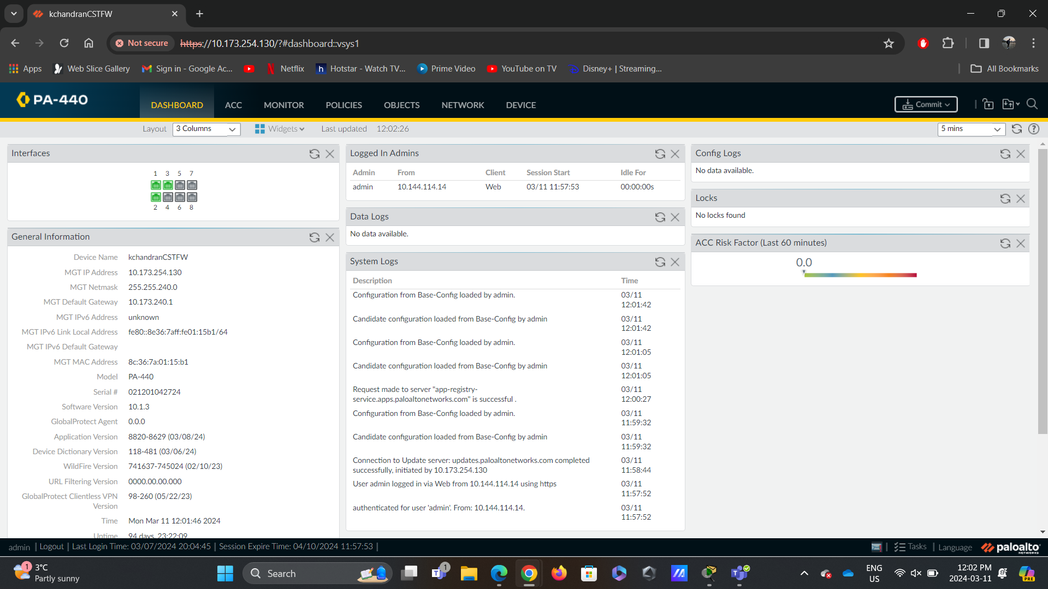

Figure 1.1: This screenshot displays the kit in “Base-config,”

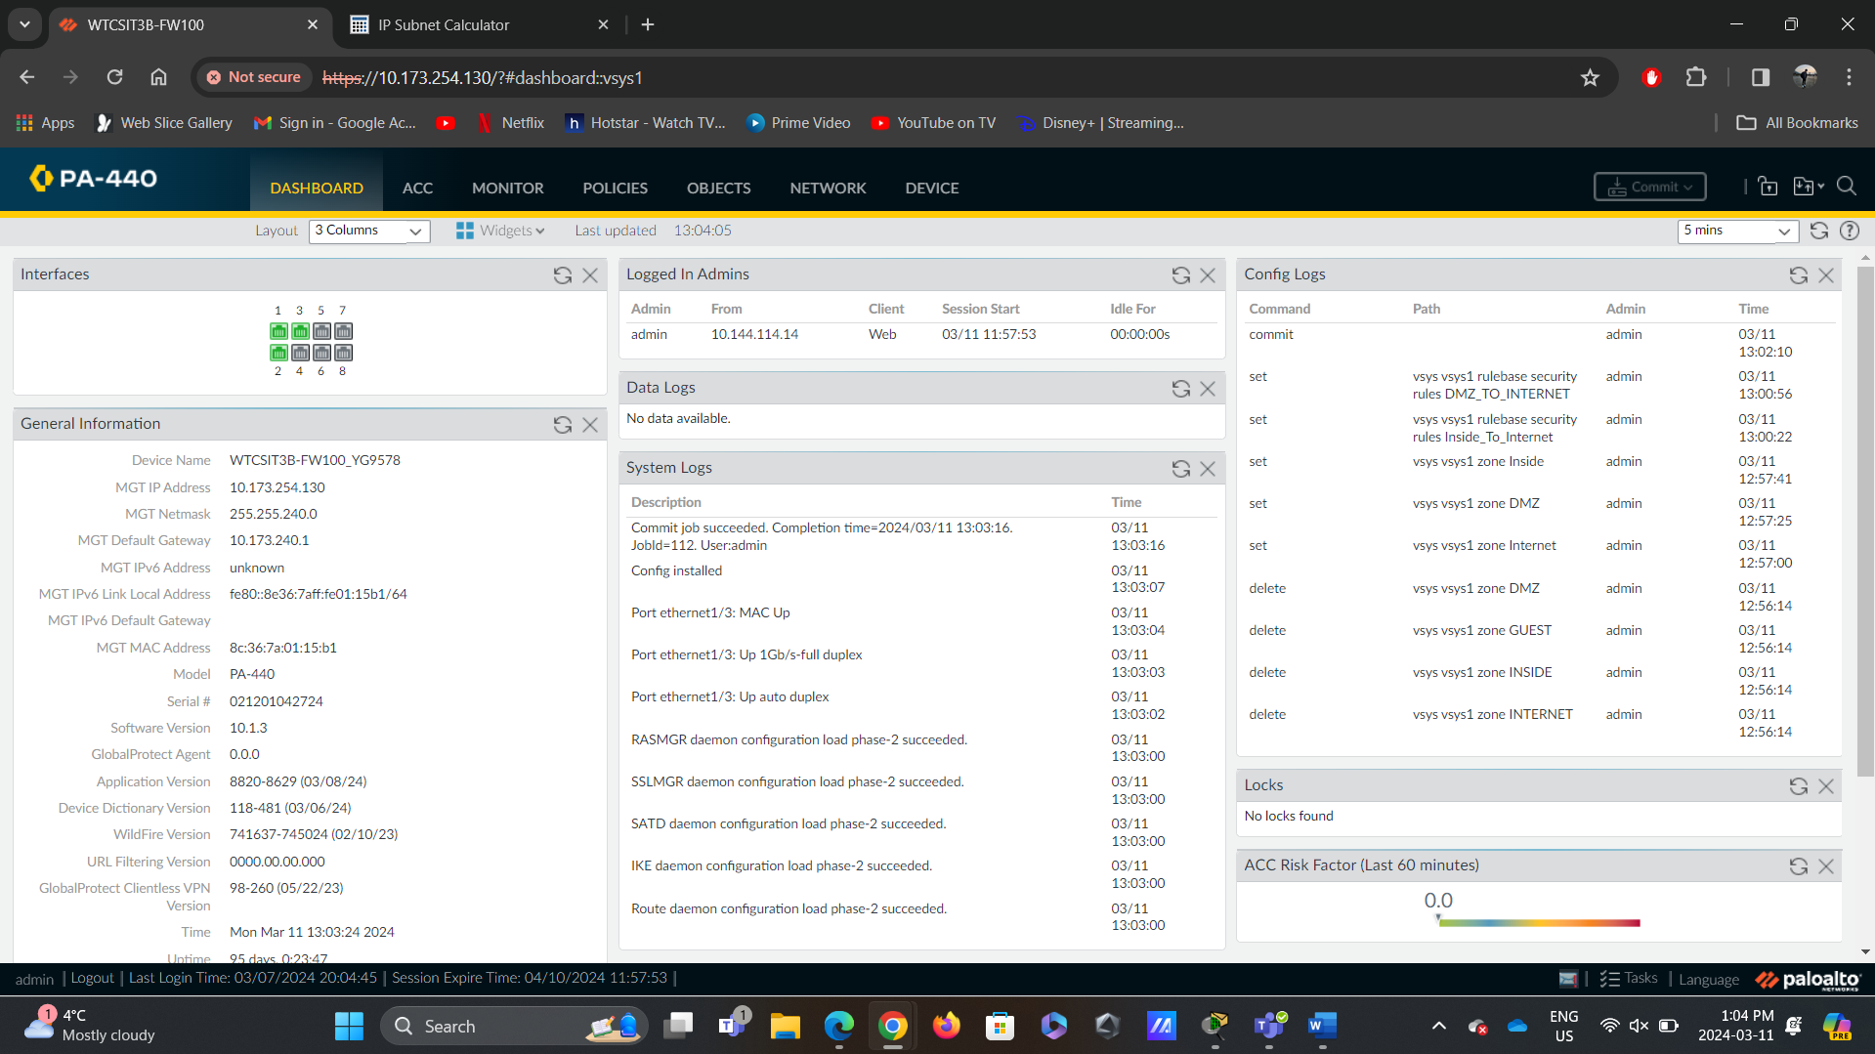

Figure 1.2: This screenshot displays the renamed kit in “Base-config.”

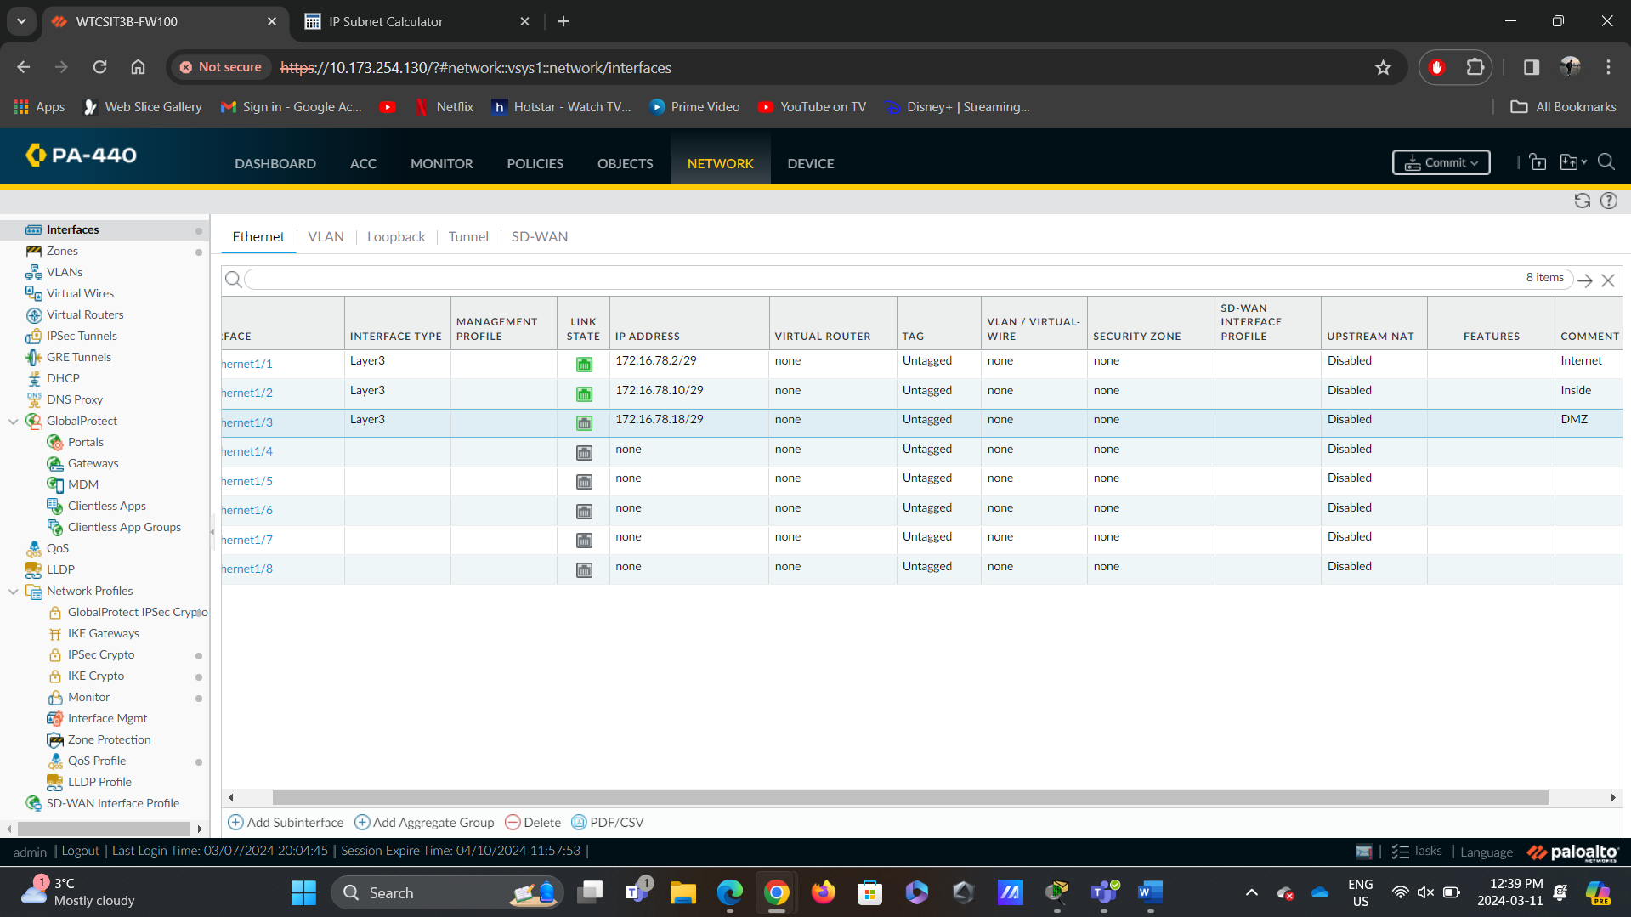

Figure 1.3: This screenshot displays the configured interfaces with IP addresses.

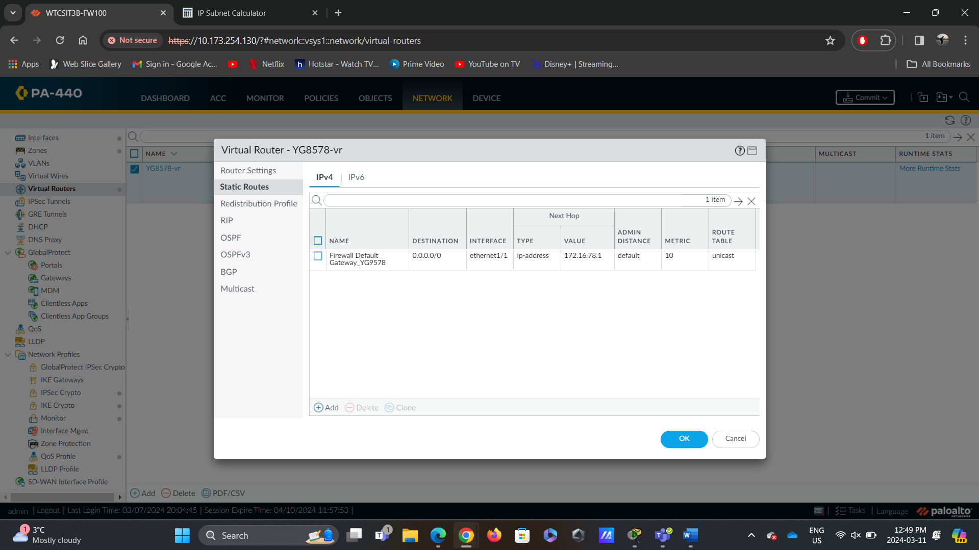

Figure 1.4: This screenshot displays the Virtual Router “static route” configurations.

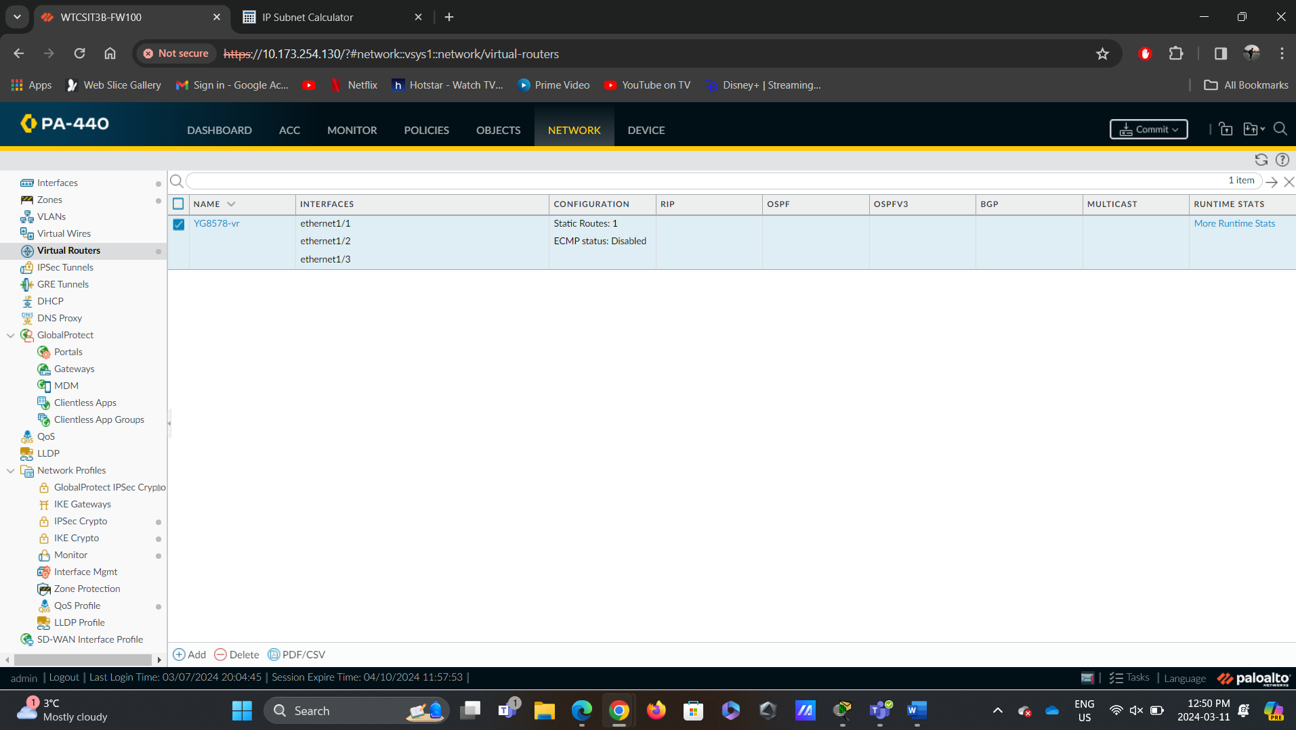

Figure 1.5: Virtual Router Configuration - Screenshot demonstrating the addition of a virtual router to enable routing between different networks, ensuring traffic isolation between zones.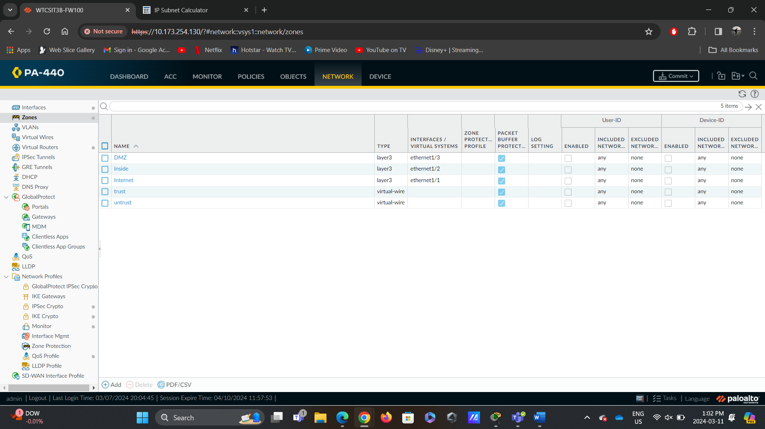

Figure 1.6: Firewall Zone Assignment - Screenshot depicting the assignment of interfaces on the firewall to specific zones, facilitating granular control over network traffic.

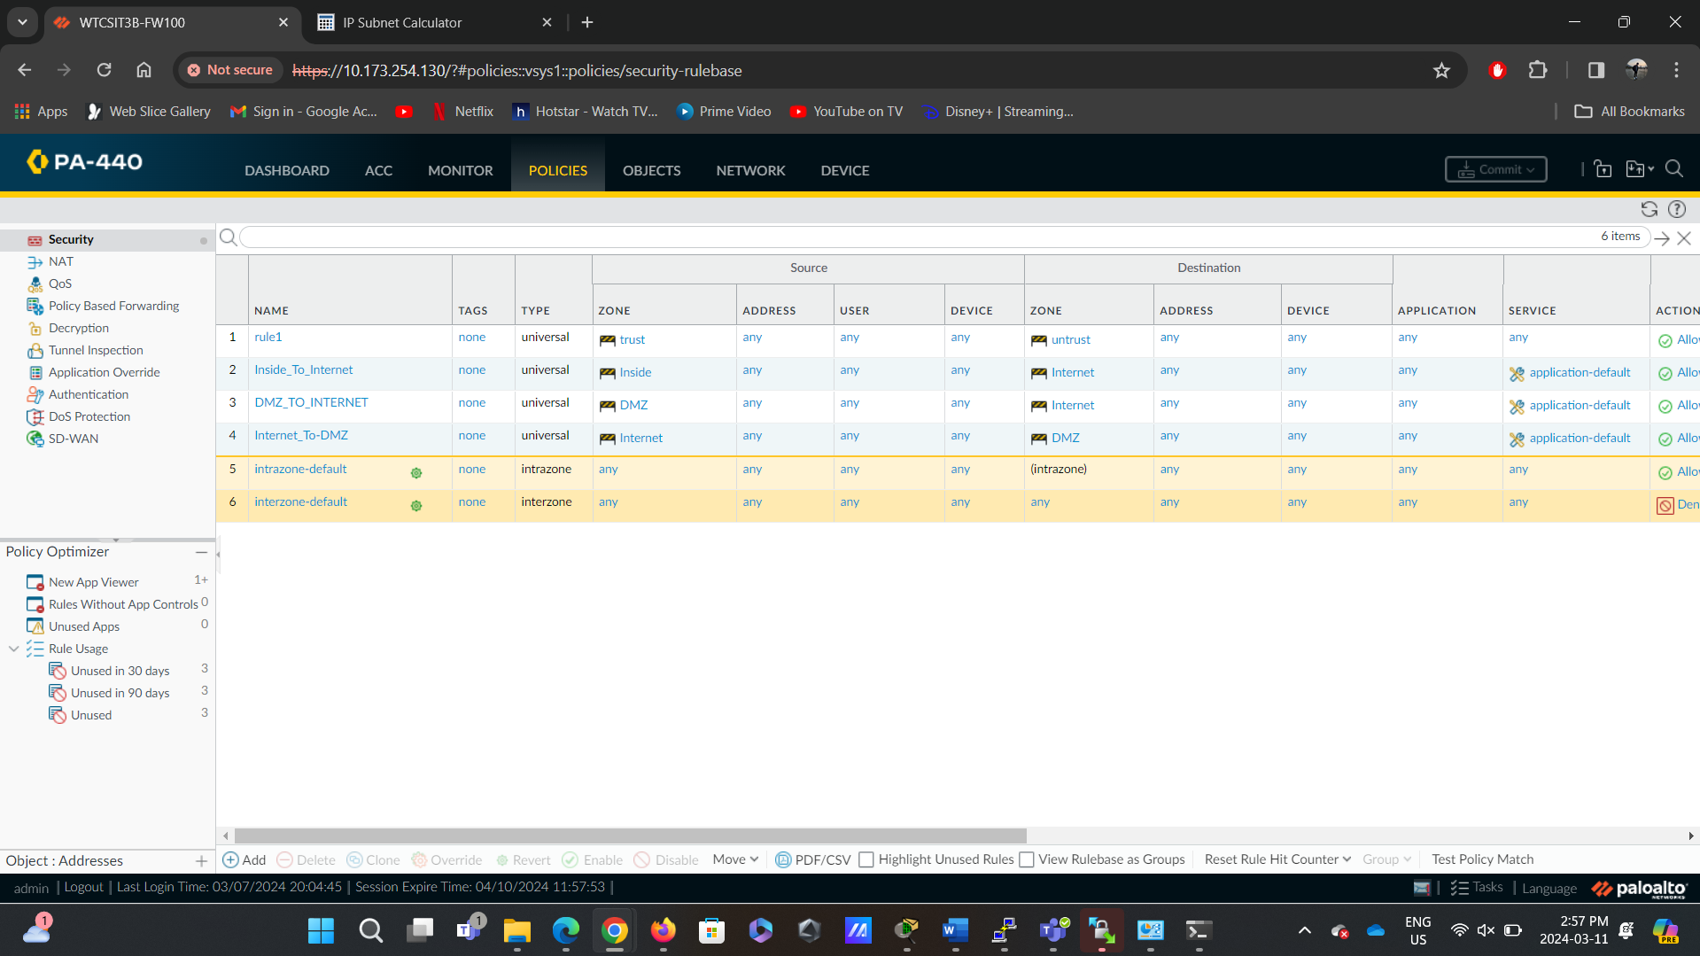

Figure 1.7: This screenshot displays the Policy configurations.

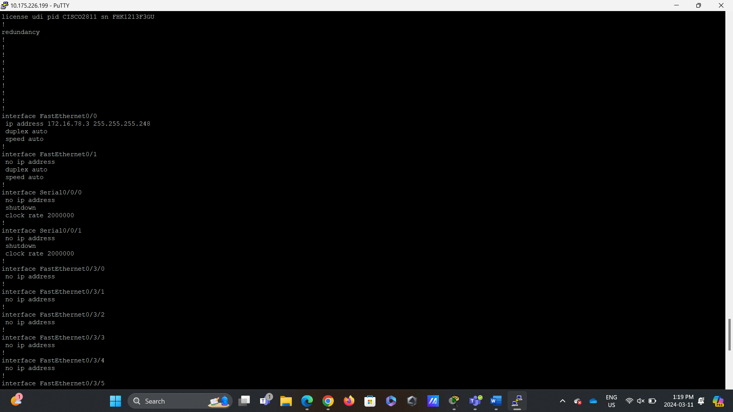

Figure 1.8: This screenshot displays the IP configurations of the Router’s interface FastEthernet 0/0.

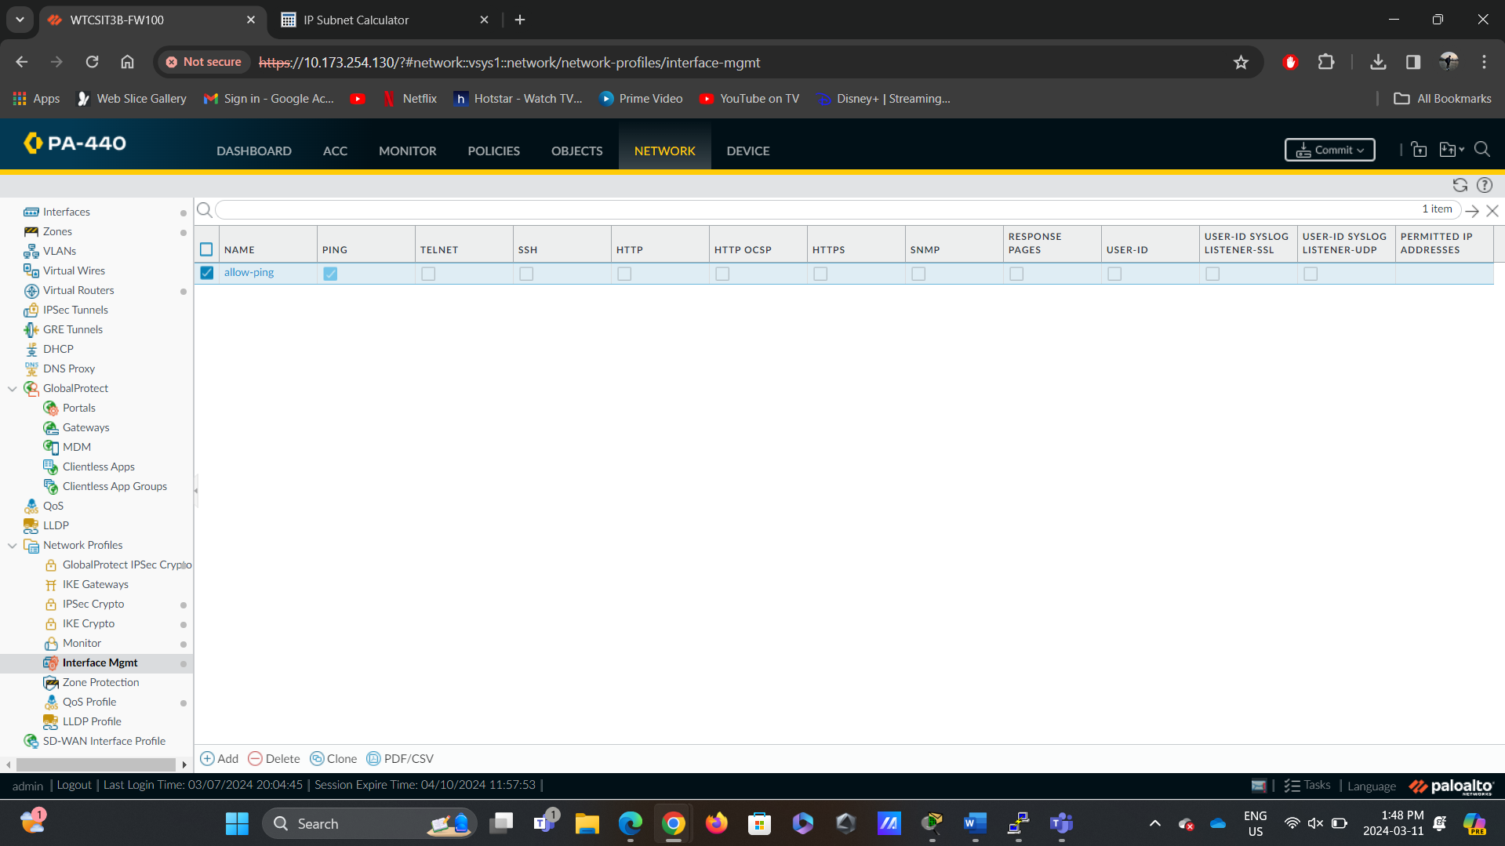

Figure 1.9: This screenshot displays the Interface Management configurations that “allow ping.”

## Reflection

Completing the initial steps of the lab, which focused on validating network connectivity and functionality, provided me with valuable insights into the foundational aspects of network security. Configuring all network components based on the provided topology required careful consideration of network architecture and device configurations. This step emphasized the importance of proper planning and adherence to established network design principles. Ensuring access to the kit highlighted the critical role of access control mechanisms in safeguarding internal resources. Validating the digital certificate on the firewall underscored the significance of certificate management practices in establishing secure communication channels. Enabling ICMP on all interfaces facilitated effective network troubleshooting and communication, enhancing overall network resilience. Confirming access to the firewall's internet interface from the outside untrusted zone reinforced the importance of perimeter security measures in defending against external threats. Overall, completing these steps provided a solid foundation for the subsequent firewall configuration for production use, laying the groundwork for implementing robust network security measures in the lab environment.

# Part 2- Configure Global Protect to allow remote access to your users:

## Description

Part 2 of the lab aims to configure Global Protect for remote access VPN (Clientless) functionality. This involves creating users for VPN access, generating and signing a digital certificate for the firewall, configuring SSL/TLS service profiles, creating specific tunnel interfaces and zones for VPN users, setting up the Global Protect Portal and Gateway, and validating the infrastructure and VPN connection. This lab aims to establish a secure and efficient remote access solution, enabling users to connect to the corporate network from external locations with a fully functional remote access VPN solution using GlobalProtect, providing users with secure and seamless access to the corporate network resources from external locations.

## Preparation

The only preparation needed was to use a Linux VM for Certificate Management: I prepared a Rocky Linux VM to generate and sign a digital certificate for the firewall. I ensured that the necessary tools and procedures were in place to complete this task, adhering to best practices for certificate management.

## Observations

Successful Configuration: The configuration of Global Protect for remote access VPN was completed without significant issues, demonstrating a clear understanding of the configuration steps.

Certificate Management: Generating and signing the digital certificate for the firewall proceeded smoothly, ensuring secure communication channels for VPN connections.

Segmentation and Isolation: Creating tunnel interfaces and zones for VPN users facilitated effective segmentation of VPN traffic within the network, enhancing security and traffic management.

User Authentication: User accounts for VPN access were created successfully, and the authentication profile was configured without difficulties, ensuring secure user authentication during VPN connections.

Validation and Testing: The infrastructure was validated, and the VPN connection was tested, confirming its functionality and security.

These observations highlight the successful completion of Part 2 of the lab and provide valuable insights into the configuration process and the functionality of the implemented solution.

## Screenshots

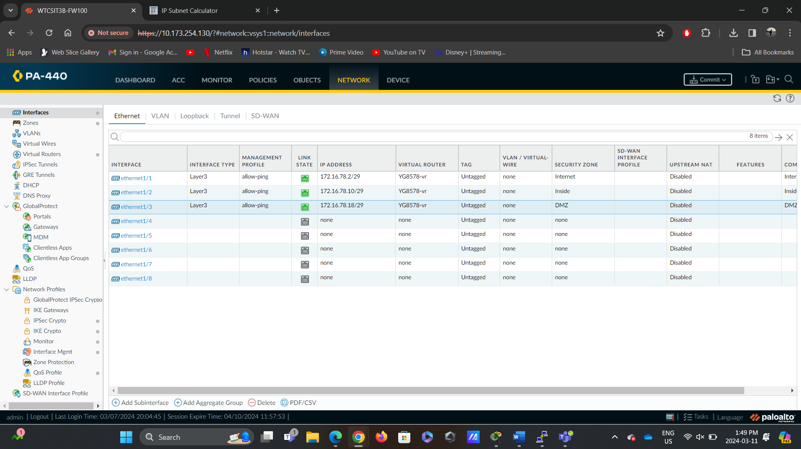

Figure 2.1: Firewall Interface Assignment - Screenshot showing the assignment of each interface to the network topology designed, ensuring proper connectivity between network components.

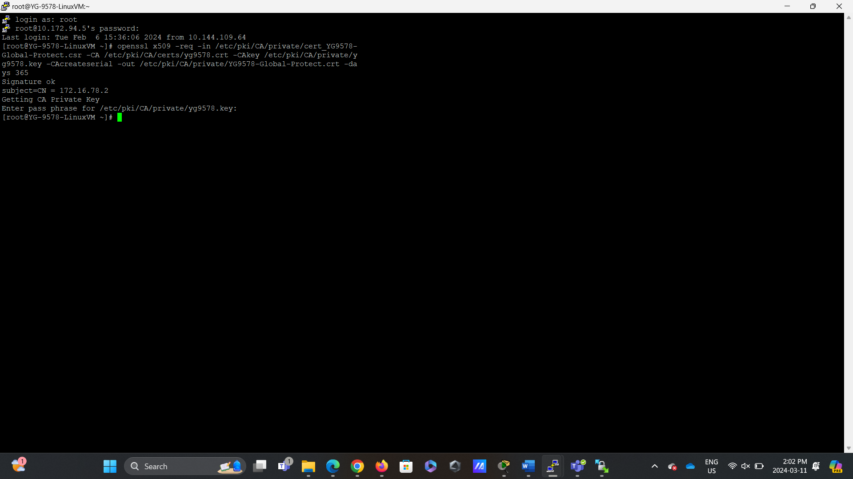

Figure 2.2: Firewall Certificate Generation - Screenshot displaying the generation and signing of a digital certificate for the firewall to establish secure communication channels for VPN connections.

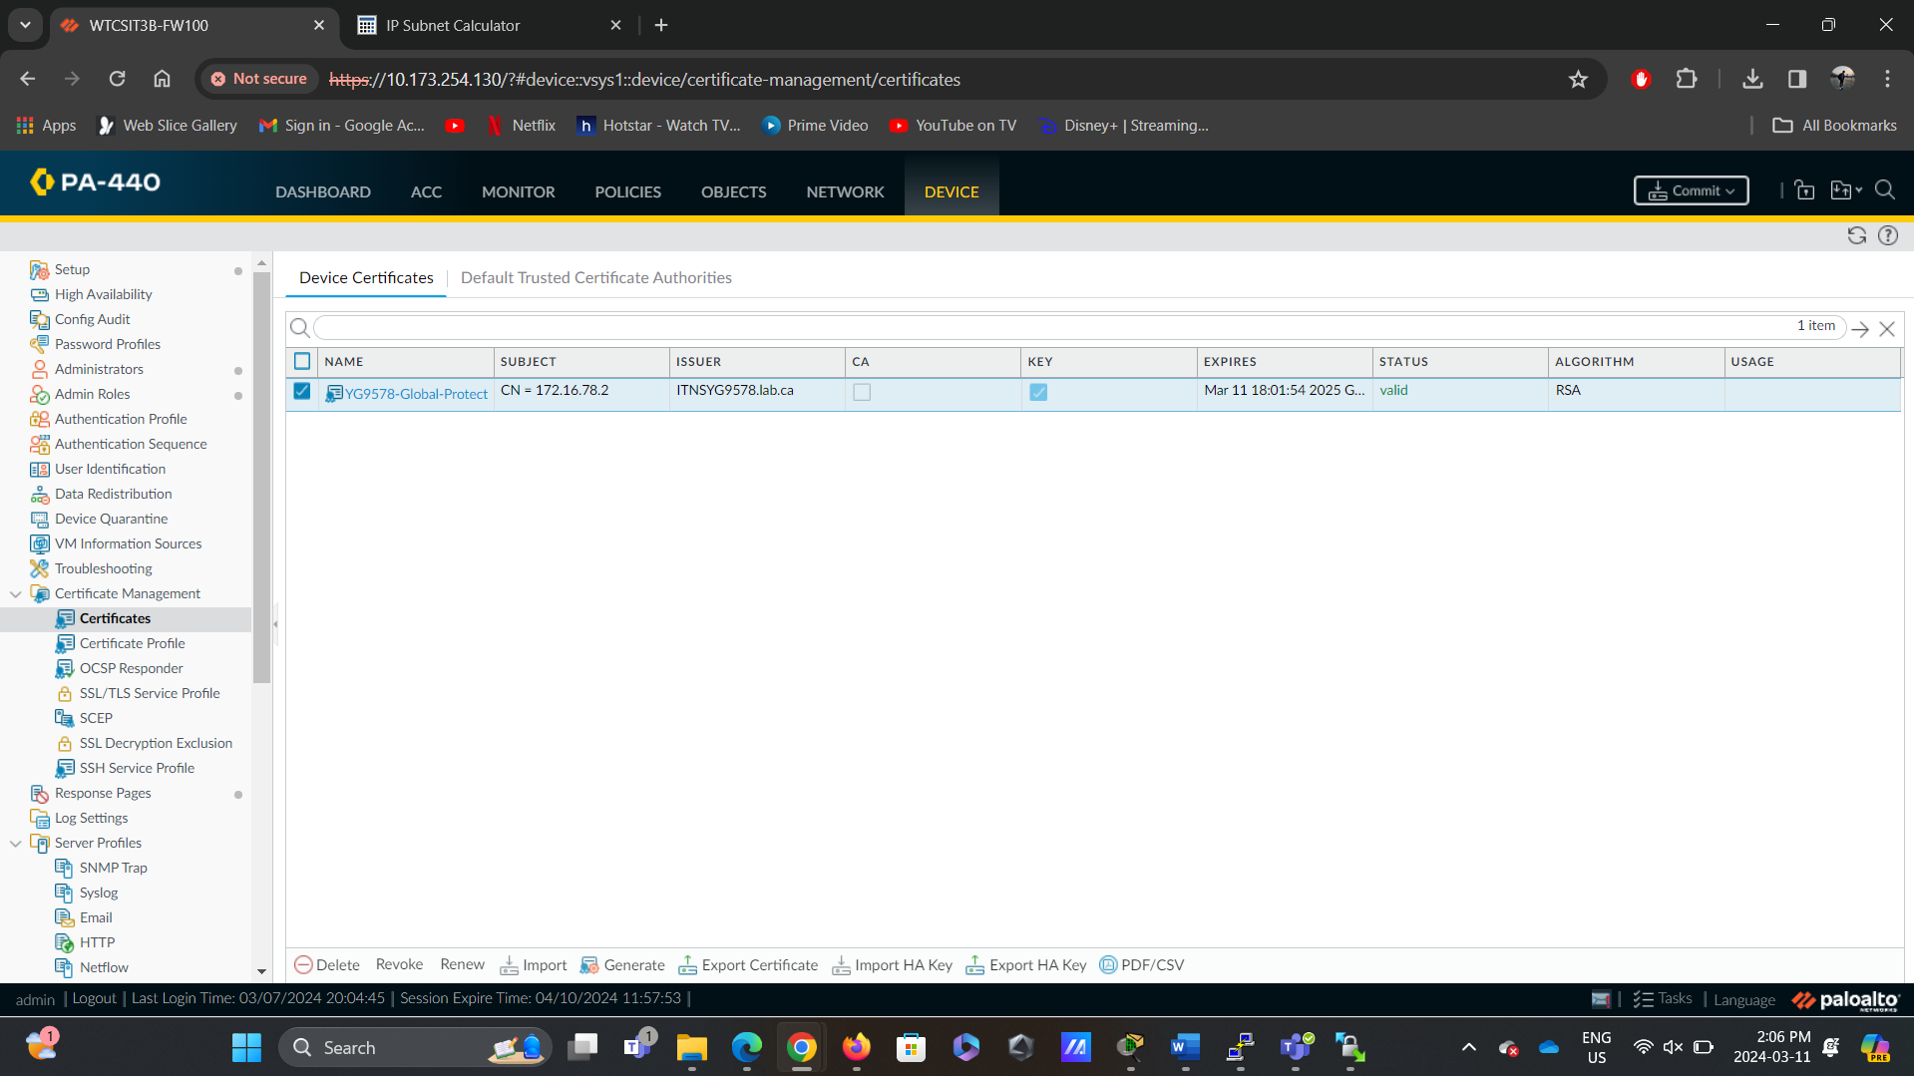

Figure 2.3: Firewall Certificate Generation - Screenshot displaying the generation and signing of a digital certificate for the firewall to establish secure communication channels for VPN connections.

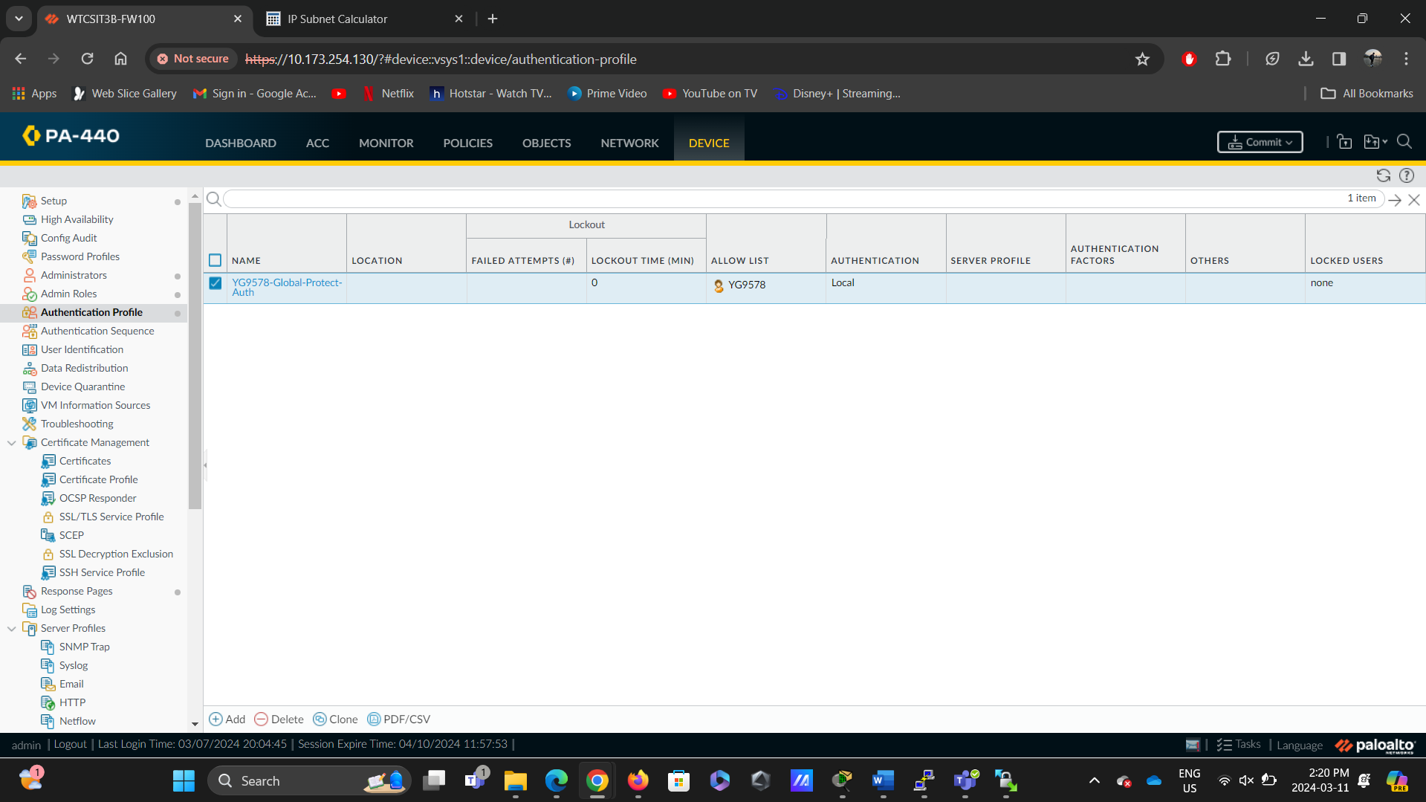

Figure 2.4: Global Protect Authentication Profile - Screenshot depicting the assignment of Global Protect Authentication Profile.

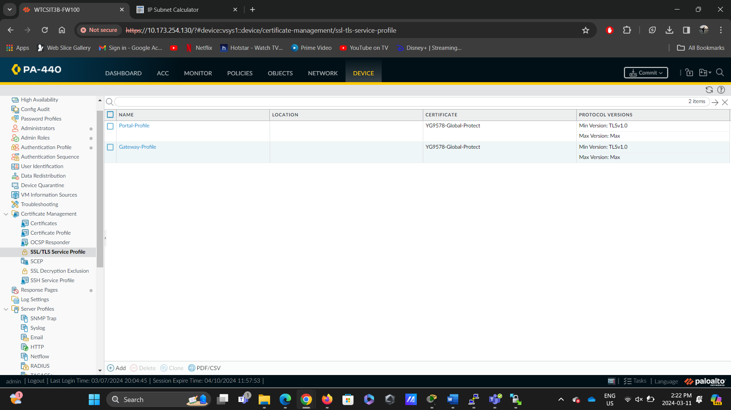

Figure 2.5: SSL/TLS Service Profile Creation - Screenshot showing the creation of an SSL/TLS service profile for the GlobalProtect Portal, defining encryption and authentication methods for secure communication.

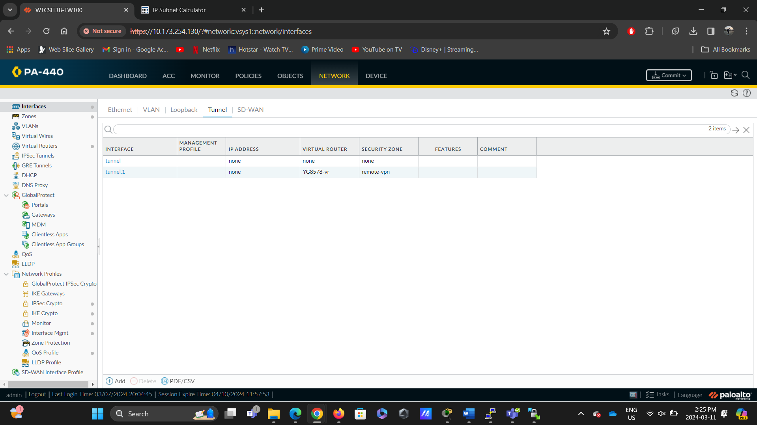

Figure 2.6: Tunnel Interface- Screenshot demonstrating the creation of a tunnel interface.

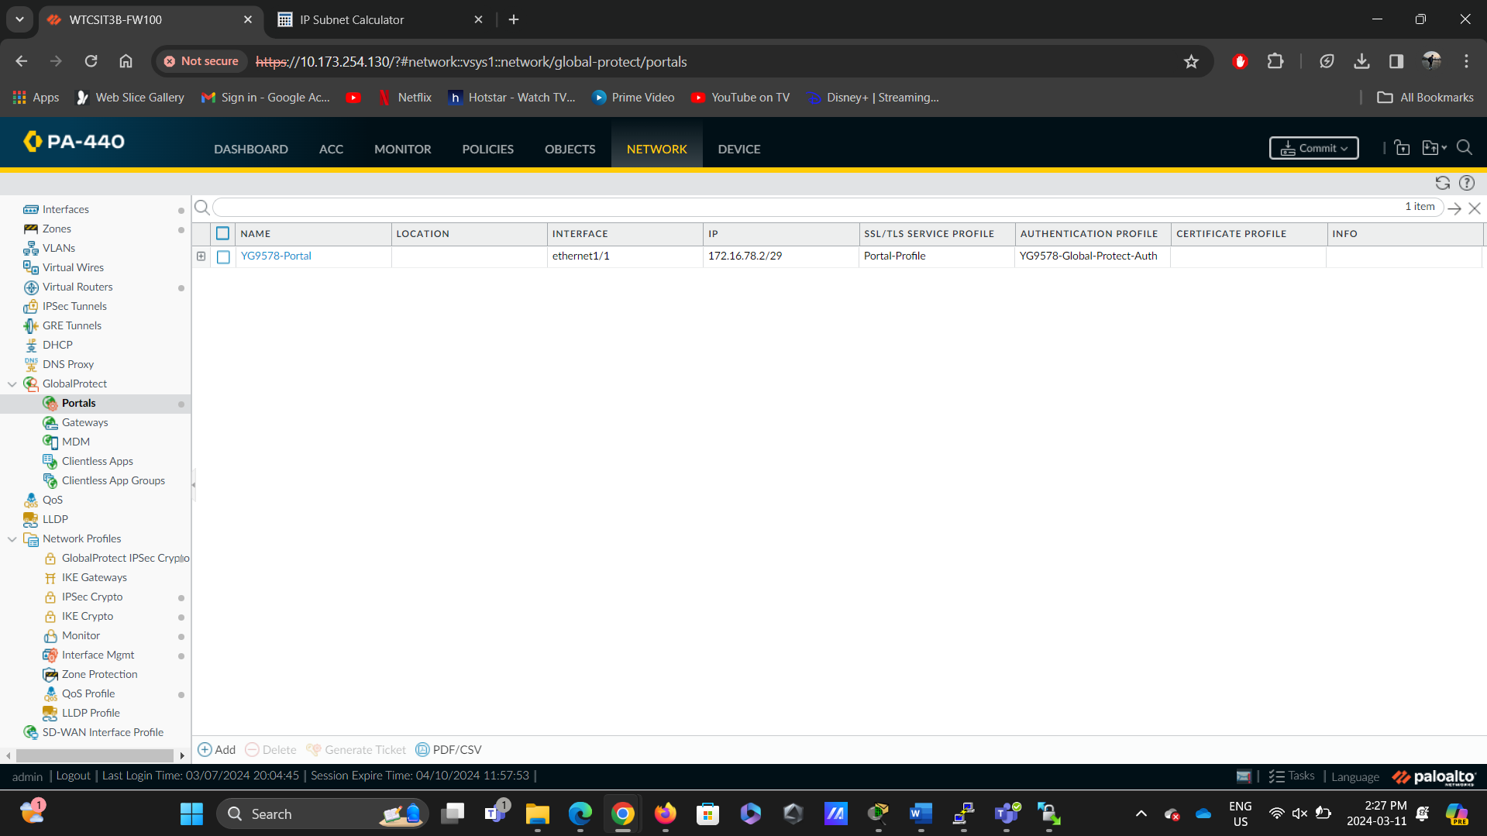

Figure 2.7: GlobalProtect Portal Configuration - Screenshot depicting the configuration of the GlobalProtect Portal, serving as the interface for VPN users to connect to the network securely.

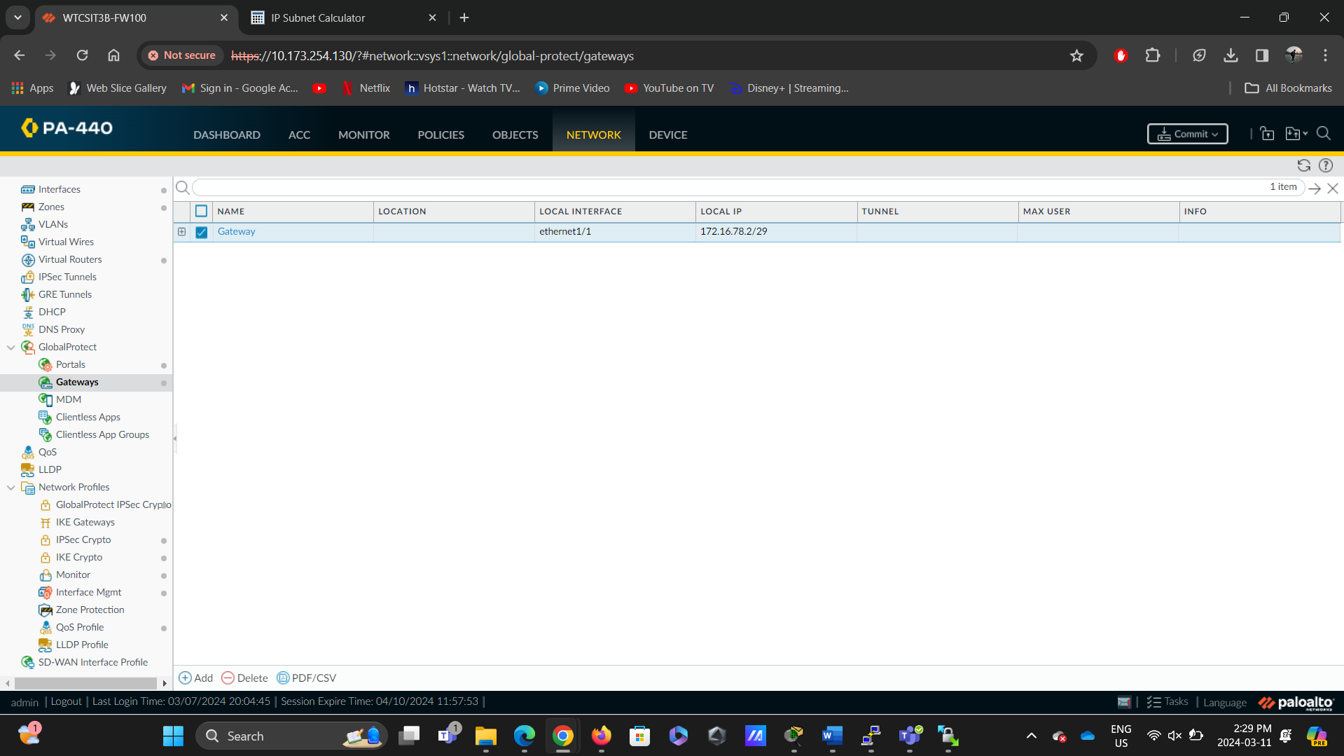

Figure 2.8: GlobalProtect Gateway Configuration - Screenshot showcasing the configuration of the GlobalProtect Gateway, facilitating secure access to internal resources for VPN connections.

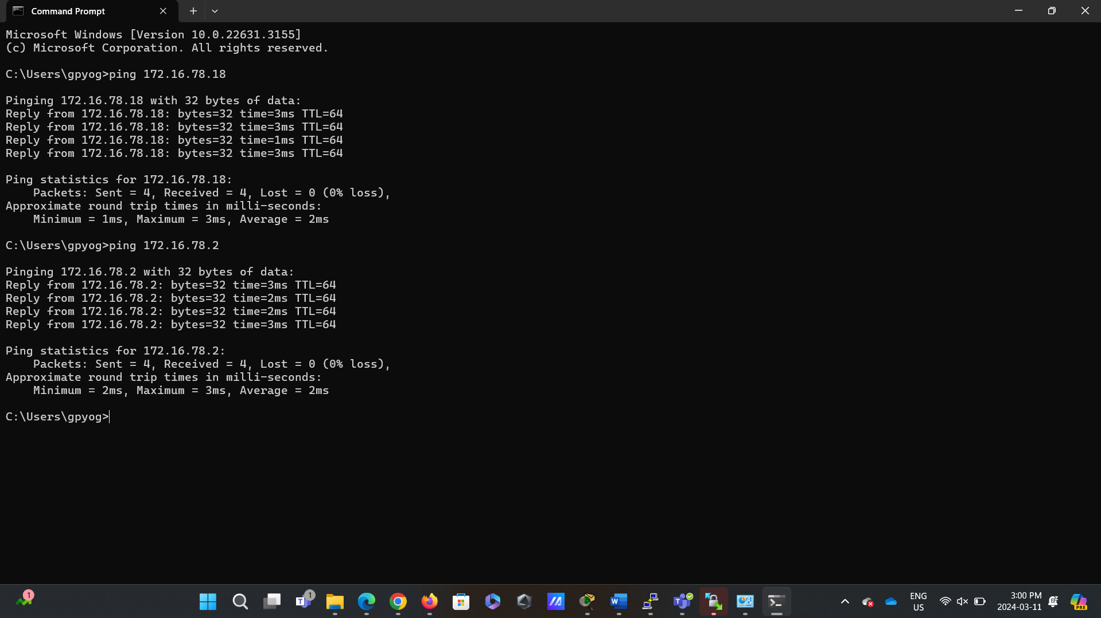

Figure 2.9: Screenshot showcasing the pinging of the Internet interface IP.

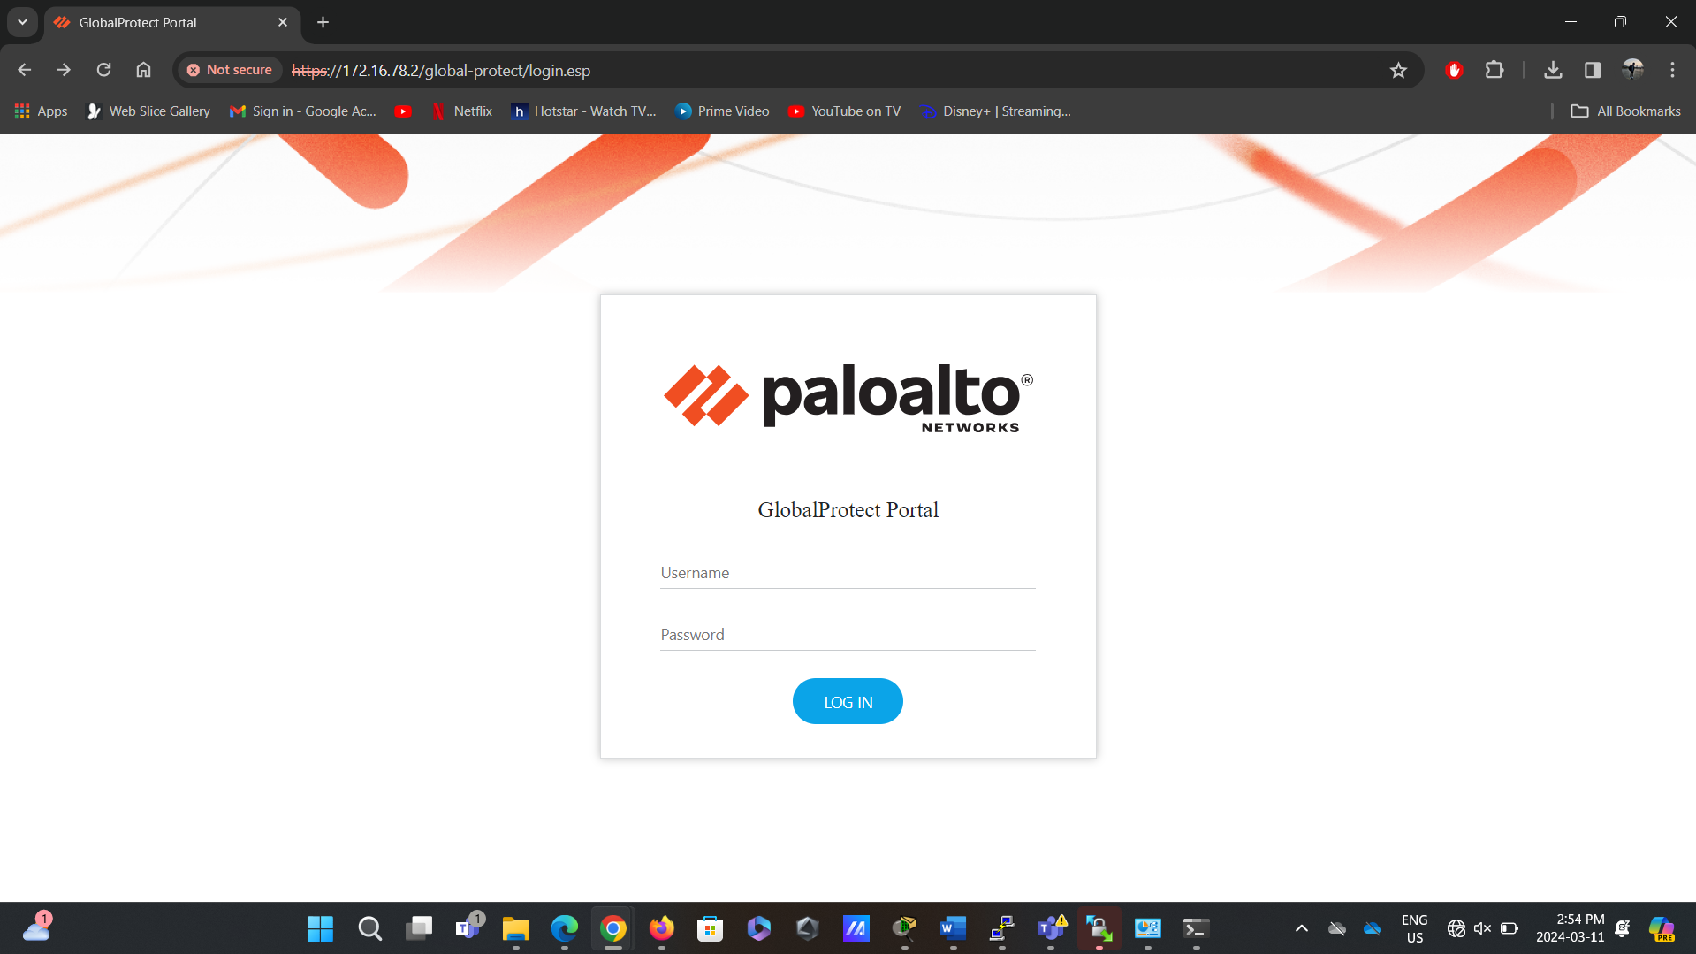  
Figure 2.10: Infrastructure Validation - Screenshot confirming the validation of the infrastructure and testing of the VPN connection to ensure functionality and security.

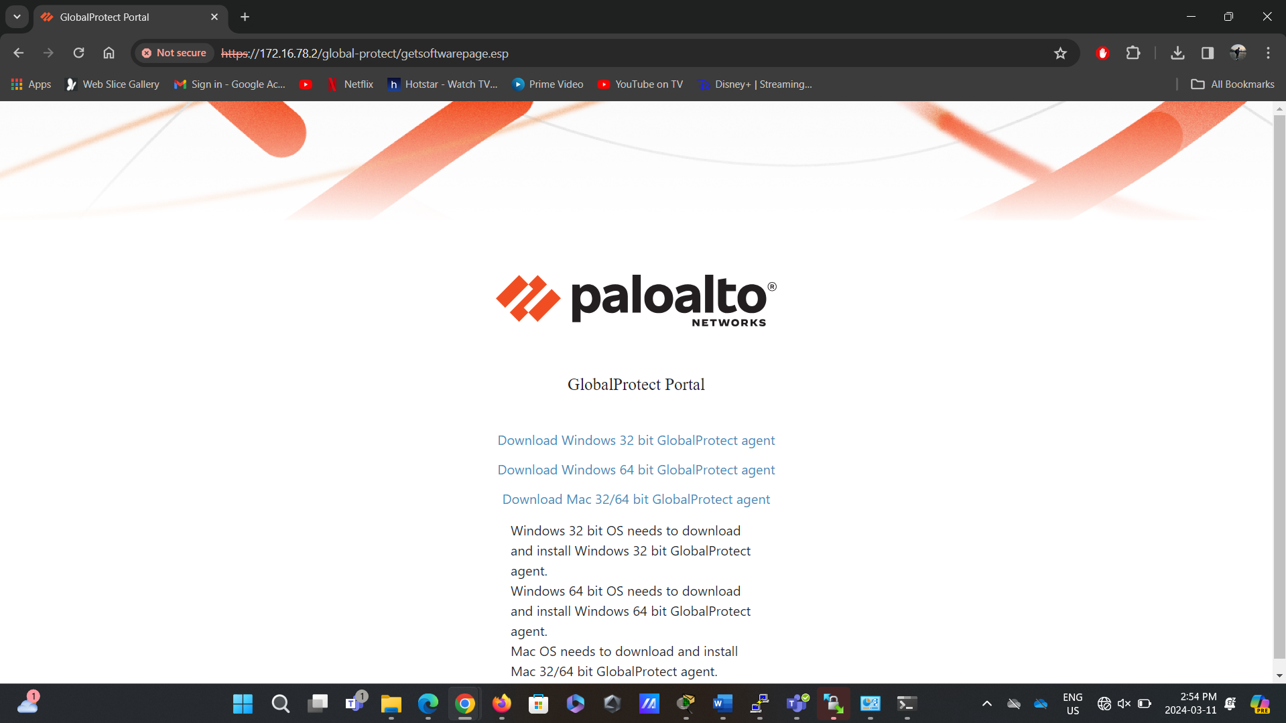

Figure 2.11: Infrastructure login Validation - Screenshot confirming the login validation of the infrastructure and testing of the VPN connection to ensure functionality and security.

## Reflection

In completing Part 2 of the lab, the achieved objective was successfully configuring GlobalProtect for remote access VPN functionality, providing users with secure and seamless access to the corporate network from external locations. This involved creating users for VPN access, generating and signing a digital certificate for the firewall, configuring SSL/TLS service profiles, creating specific tunnel interfaces and zones for VPN users, setting up the GlobalProtect Portal and Gateway, and validating the infrastructure and VPN connection. Additionally, the lab facilitated the discussion of the topology and firewall zones created, highlighted through a network diagram reflecting the network architecture. The network diagram served as a visual representation of the network layout and traffic flow, aiding in understanding the segmentation and isolation of network components for enhanced security. Overall, completing Part 2 of the lab provided practical experience in deploying and configuring remote access VPN solutions, reinforcing the importance of robust security measures in enabling secure remote connectivity to corporate networks.

# Lab 5- Monitoring Network Traffic (IP/IDS)

# Part 1- Installation of the packages and SNORT

## Description

This lab section focuses on deploying the essential components required for setting up a network intrusion detection system (NIDS) using SNORT on Rocky Linux. The primary objective is installing three key packages: EPEL-RELEASE, DNF, and SNORT. EPEL-RELEASE provides access to additional software packages, while DNF facilitates smooth package management. The open-source intrusion detection system or SNORT is the core component in charge of examining network traffic to identify and address possible security risks. By completing this part of the lab, I established the foundation for configuring SNORT to monitor and protect network infrastructure effectively.

## Preparation

Rocky Linux VM IP: 10.172.94.15

The commands to install EPEL-RELEASE, DNF, and SNORT were executed smoothly.  
But I had to use the command “sudo yum install libdnet” to install libdnet packages mainly because I encountered an error while executing snort in part 2, and I learned that libnet packages are essential for the running of snort from the forums (mentioned in references).  
An additional “GIT” package was also deployed with the command “sudo yum install git” to avoid problems later. These two commands were not present in the lab documentation.

## Observations

Several key observations can be made during the installation process outlined in Part 1 of the lab. Firstly, adding the EPEL repository facilitates access to a broader range of software packages, enhancing the system's capabilities. Secondly, the adoption of DNF as the package manager streamlines the installation and management of software components, providing a more efficient workflow. Finally, the successful installation of SNORT marks a significant milestone in establishing a robust network security infrastructure, laying the groundwork for subsequent configuration and implementation tasks in the lab.   
Installation of Libdnet packages ensures the smooth functioning of Snort in the later stages.   
An additional “GIT” package was also deployed. These two commands were not present in the lab documentation. These observations highlight the importance of proper package management and the role of SNORT as a cornerstone in network intrusion detection.

## Screenshots

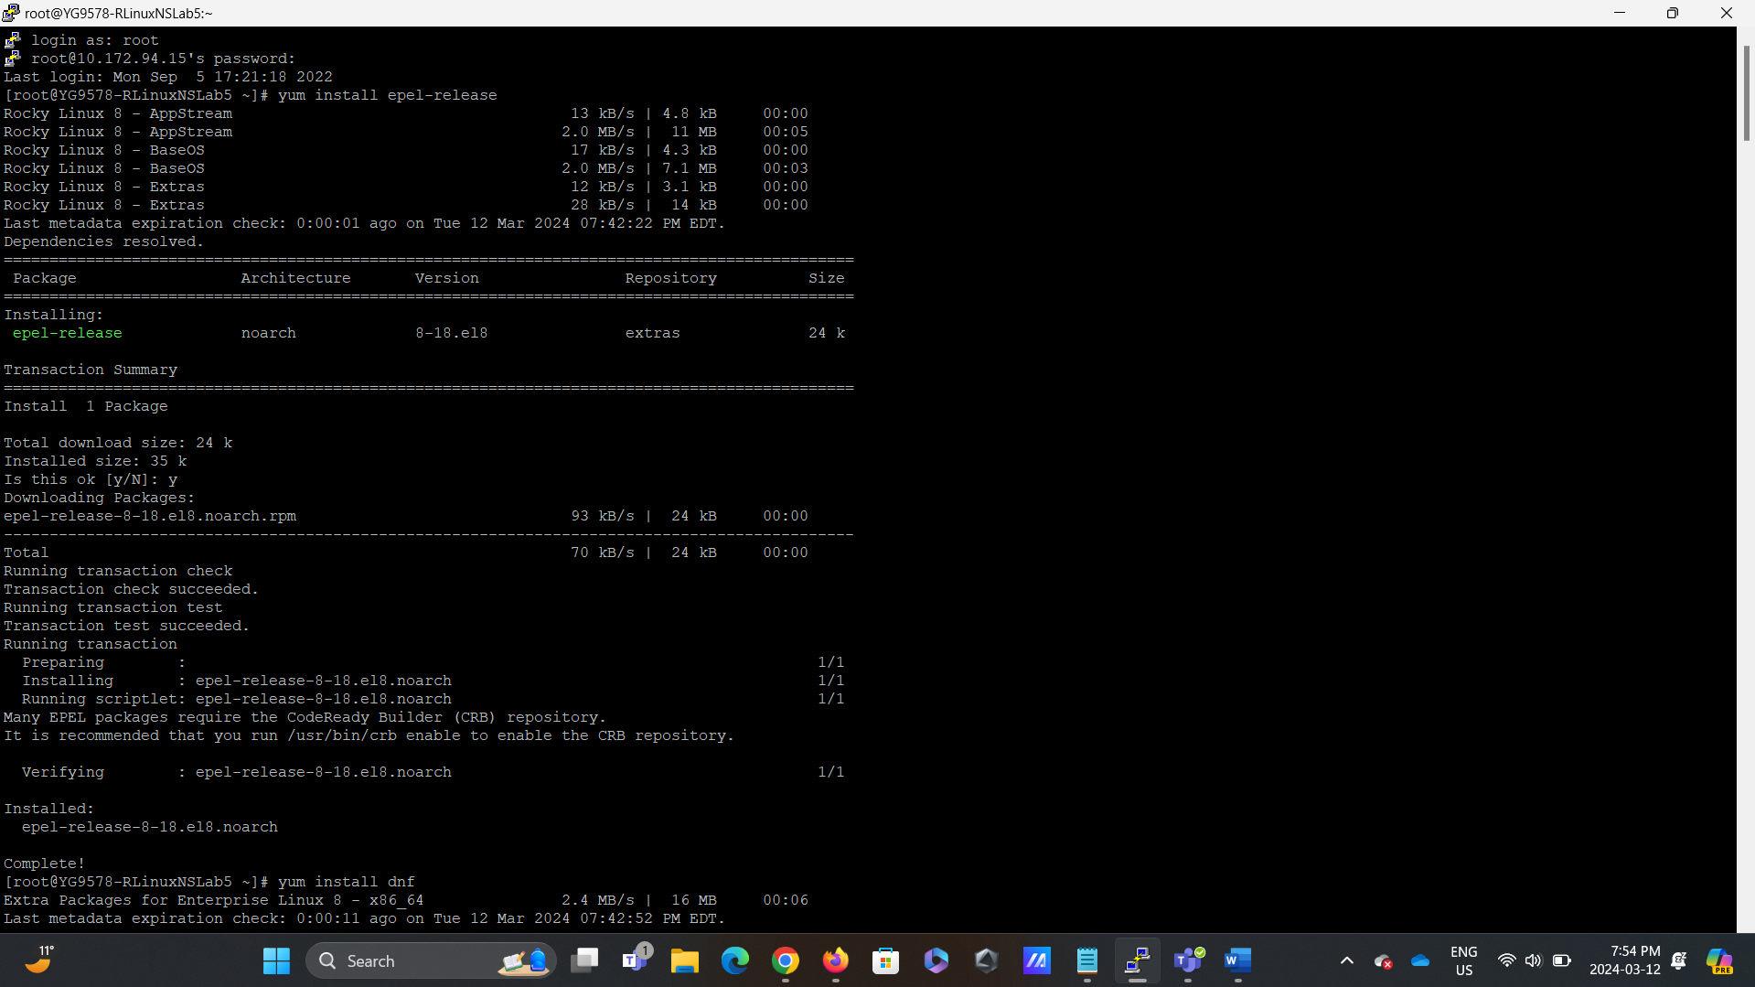

Figure1.1: Terminal Screenshot - Installing EPEL-RELEASE

This screenshot captures the terminal session during the installation of the EPEL-RELEASE package on RockyLinux. The user executes the command yum install epel-release to add the EPEL repository, expanding the available software packages for the system.

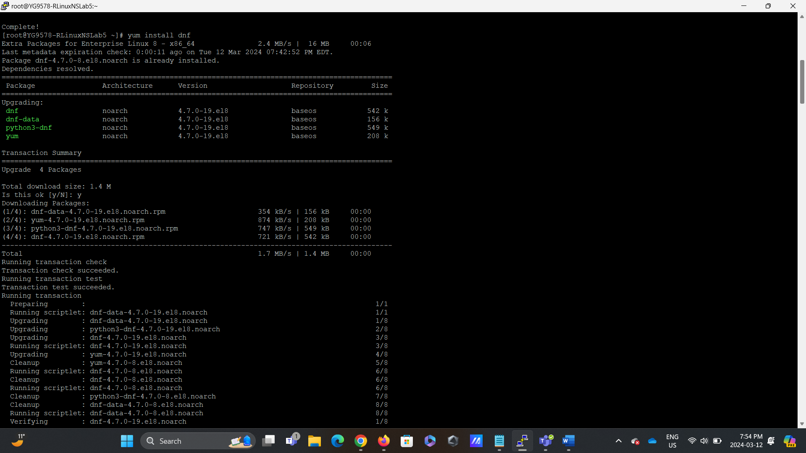

Figure1.2: Terminal Screenshot - Installing DNF

In this screenshot, the user installs the DNF package manager on RockyLinux using the command yum install dnf. DNF is the next-generation package manager that simplifies package management tasks and prepares the system for installing SNORT and other software components.

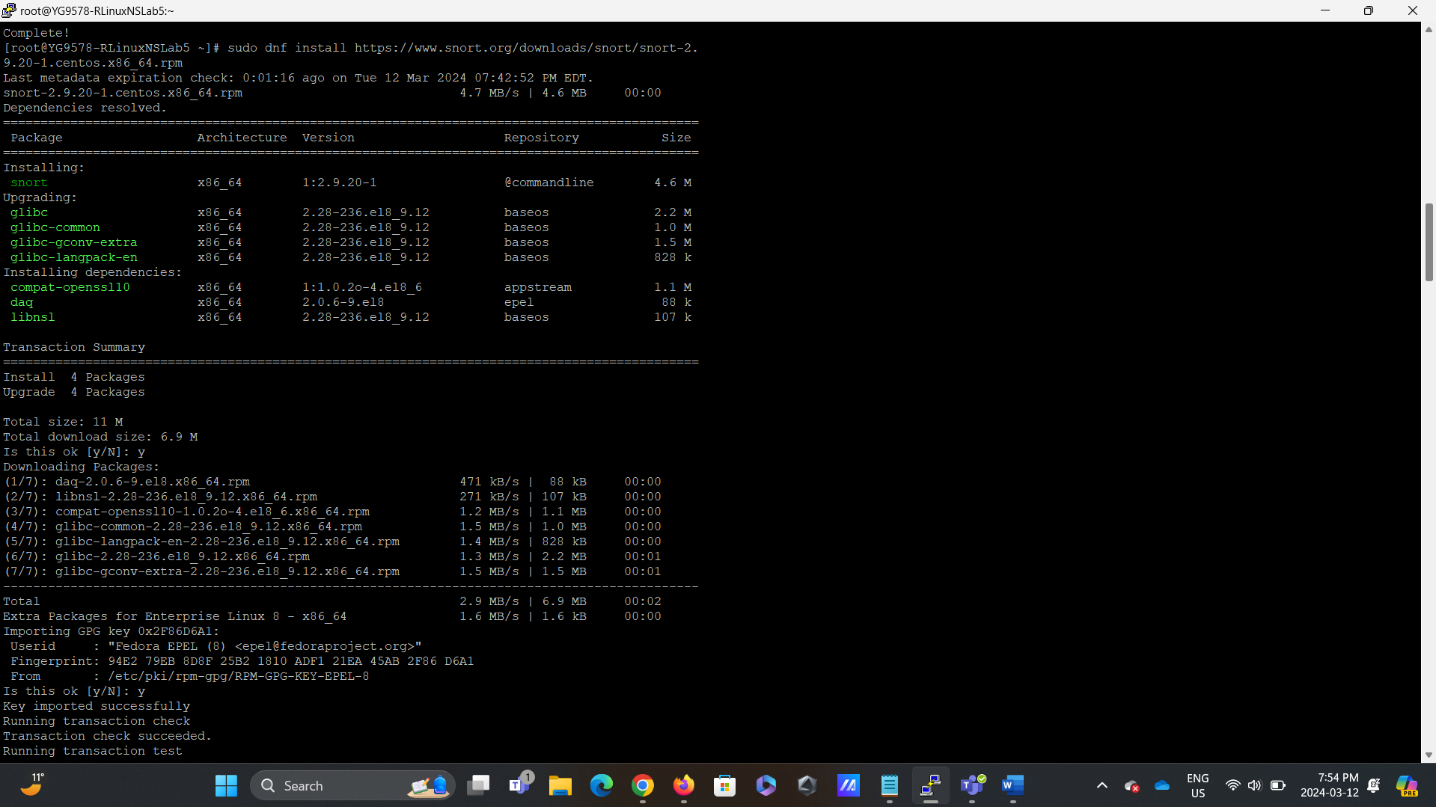

Figure1.3: Terminal Screenshot - Installing SNORT

This screenshot depicts the installation of SNORT, the open-source intrusion detection system, on RockyLinux. The user downloads and installs the SNORT package from the official SNORT repository using the command dnf install https://www.snort.org/downloads/snort/snort-2.9.20-1.centos.x86_64.rpm.

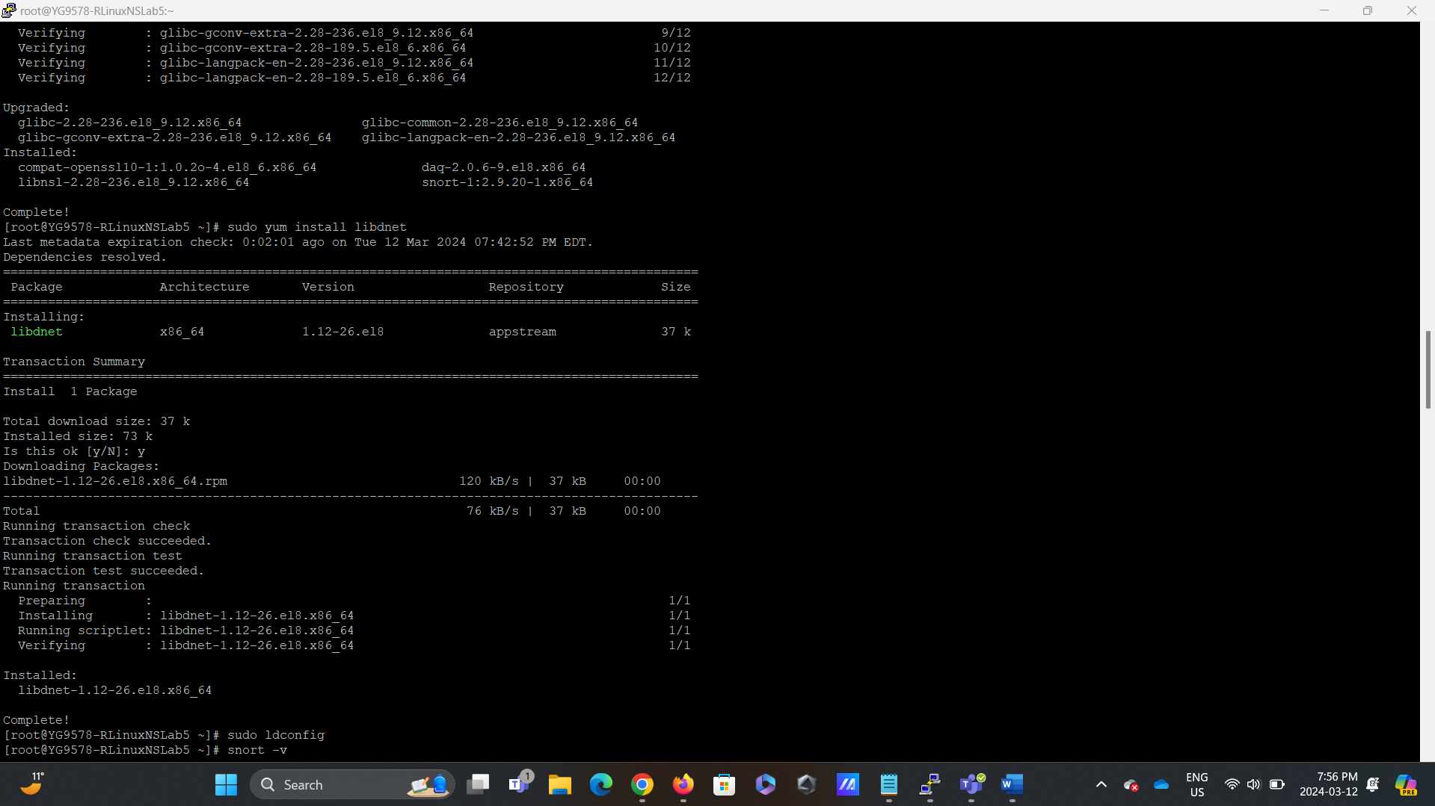

Figure 1.4: This screenshot displays the installation of:” libdnet.”

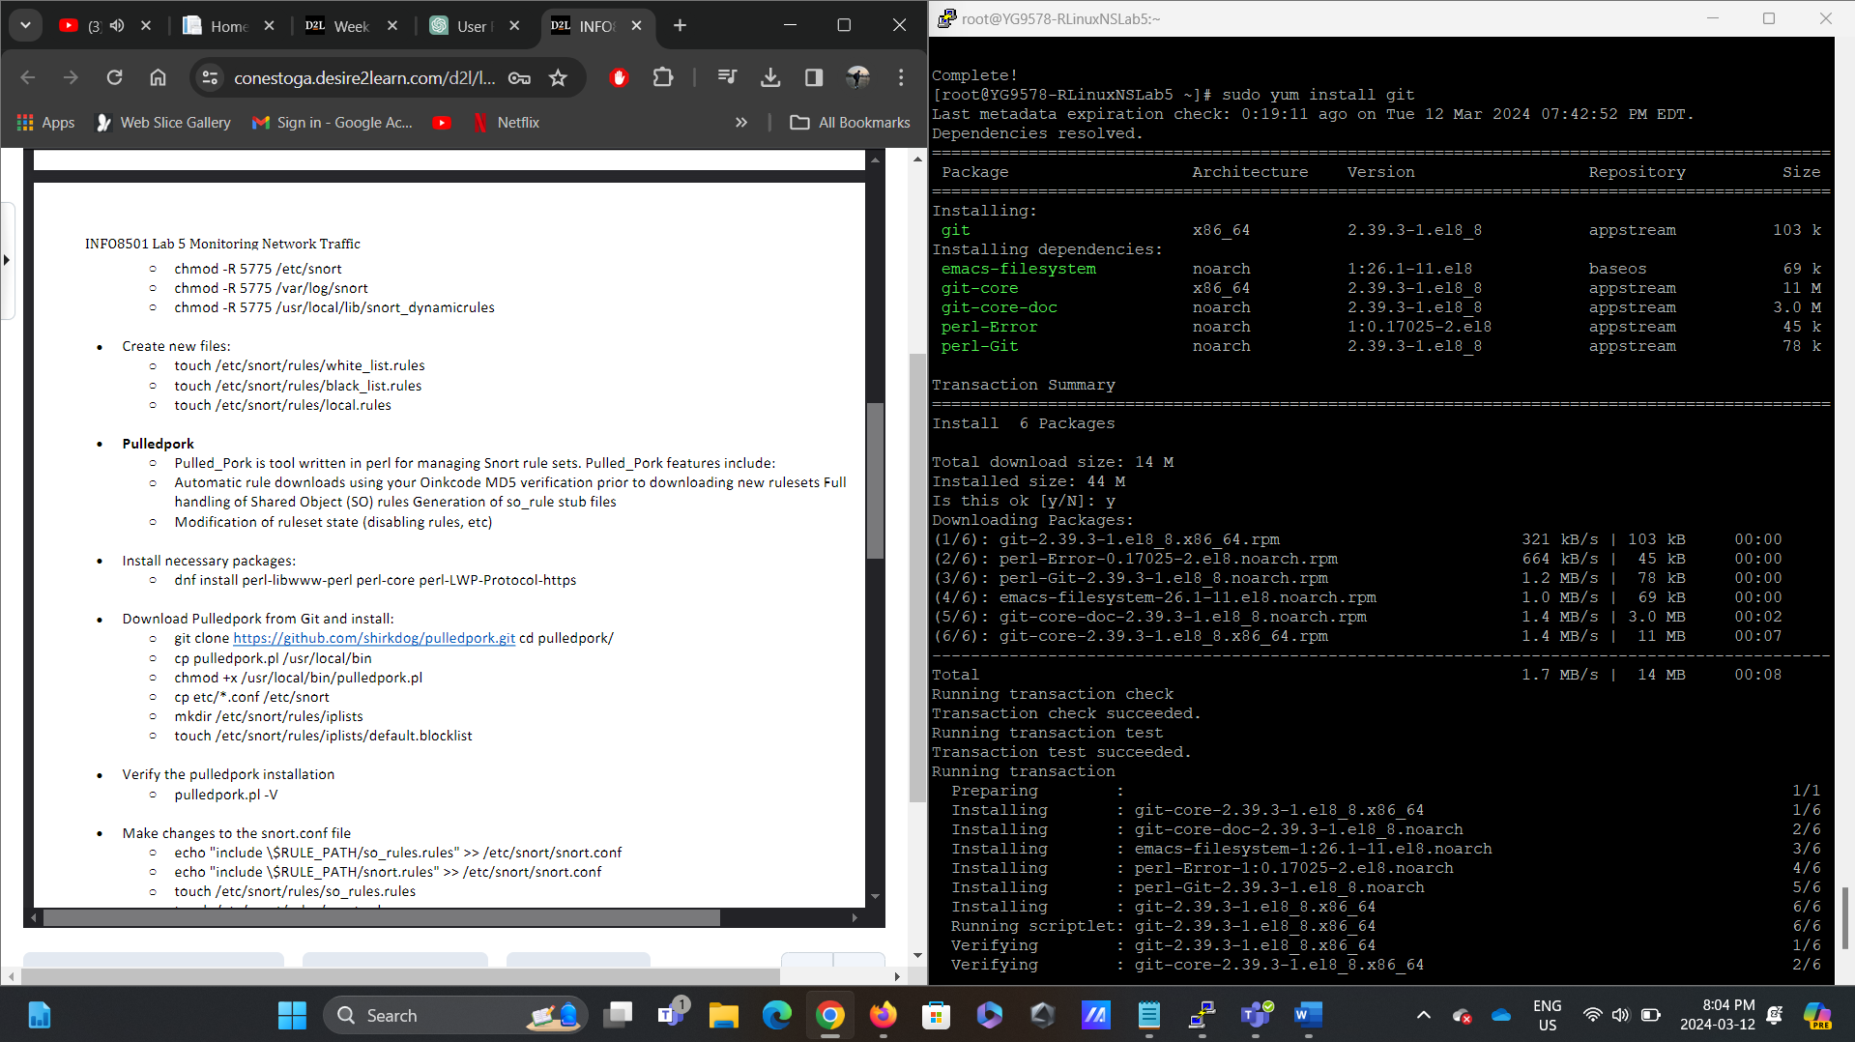

Figure 1.4: This screenshot displays the installation of:” git.”

## Reflection

The installation process of the required packages and SNORT in Part 1 of the lab provided valuable insights into the foundational elements of network security infrastructure. Firstly, including the EPEL repository expanded the range of available software packages, underscoring the importance of leveraging external repositories to enhance system functionality. Additionally, transitioning to DNF as the package manager showcased the evolution of package management tools in Rocky Linux, emphasizing the need to adapt to newer technologies for improved efficiency and reliability. Moreover, the successful installation of SNORT demonstrated the critical role of intrusion detection systems in safeguarding network integrity against potential threats. This installation process laid the groundwork for subsequent configuration tasks and underscored the significance of proper package management and robust security measures in maintaining a resilient network environment.

# Part 2- Configuring SNORT for IDS

## Description

In Part 2 of the lab, we begin configuring SNORT as an intrusion detection system (IDS). This involves several key steps to effectively set up SNORT to monitor and detect malicious network traffic. The process begins with ensuring proper library configurations with “ldconfig” and verifying the SNORT installation with “snort -v.” Next, essential directories are created to organize SNORT's rule sets and log files. Permissions are then set for these directories to ensure proper access. The configuration continues with creating new rule files, including white_list.rules, black_list.rules, and local. Rules allow for custom rules to be added later. The PulledPork tool is introduced to manage SNORT rule sets efficiently, enabling automatic rule downloads and modifications. Necessary Perl packages are installed to support PulledPork's functionality, and the tool is configured to work with SNORT. Changes are made to the snort. The conf file should correctly include rule sets and paths. Additionally, users are instructed to sign up for a SNORT account to obtain an Oinkcode used in the PulledPork configuration. Finally, the network and rule sets are configured in the snort.conf file and the SNORT configuration is verified. The lab concludes with instructions on testing SNORT by adding rules to the local. Rules file and running SNORT in test mode. Overall, this lab part aims to equip participants with the skills to configure SNORT as an effective IDS for monitoring and protecting network traffic.

## Preparation

I had to sign up for snort.org to generate an OINK code to be pasted into the pulled-pork config file.  
Oink code: d28401a60cfac330665991e3e30fbdde1a185bbd.

## Observations

Firstly, creating directories and setting permissions highlighted the importance of proper organization and access control in managing SNORT's rule sets and log files. This step ensured SNORT could efficiently store and access the necessary data for effective network monitoring. Additionally, introducing the Pulled Pork tool provided insights into the automation capabilities for managing SNORT rule sets. Pulled Pork’s ability to download and modify rule sets automatically streamlines the rule management process, enhancing the agility and responsiveness of the IDS. Furthermore, configuration changes were made to the snort.conf file underscored the flexibility and extensibility of SNORT, allowing for fine-grained control overrule sets and network configurations. Overall, the configuration process revealed the intricate details involved in setting up SNORT as an IDS, and testing ensured its effectiveness in detecting network threats.

## Screenshots

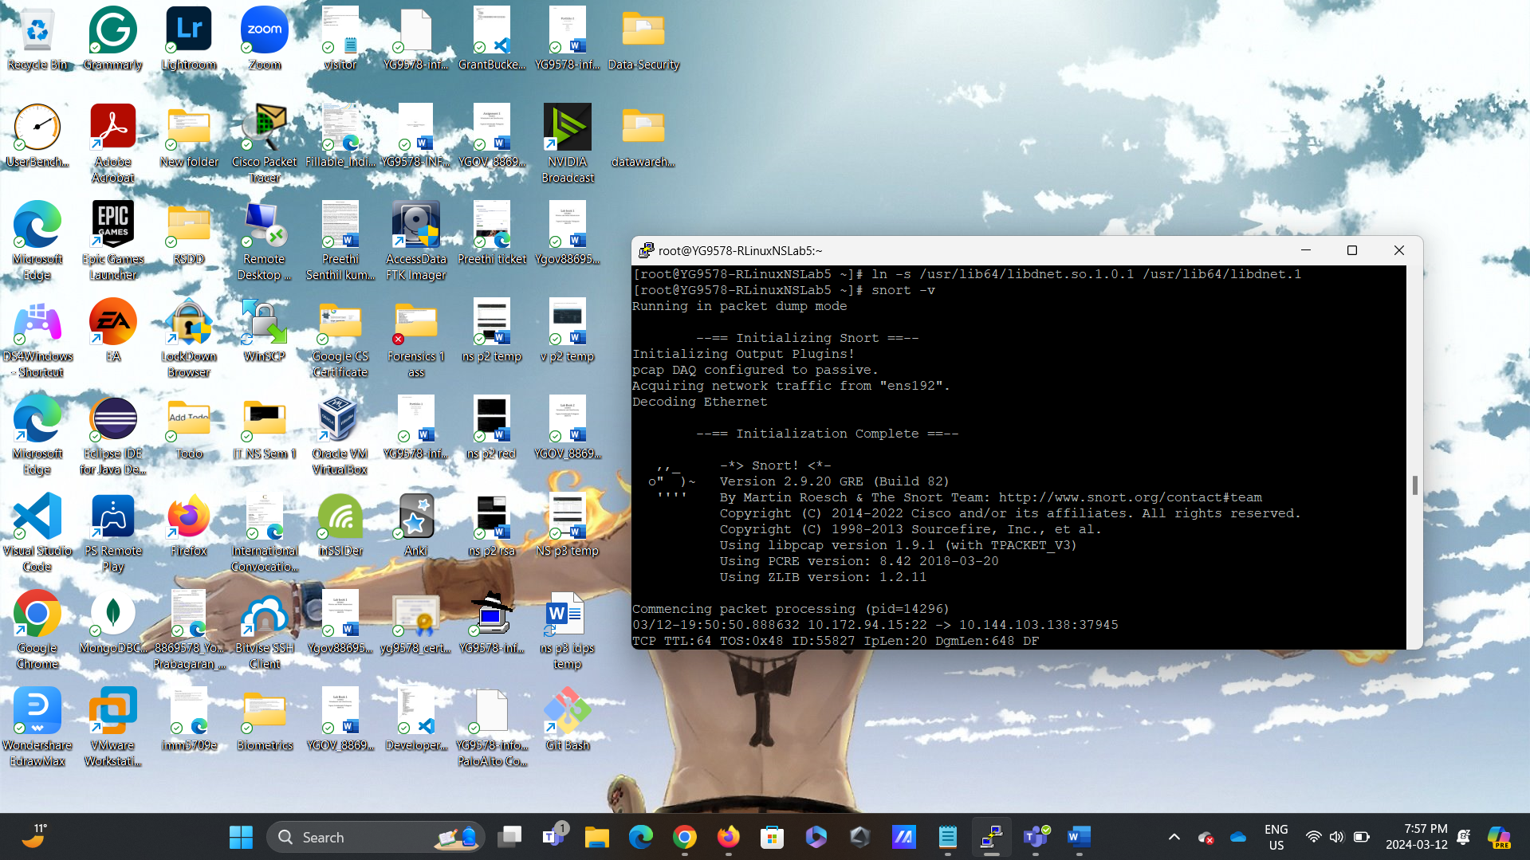

Figure 1.5: This screenshot displays the command output- “snort -V.”

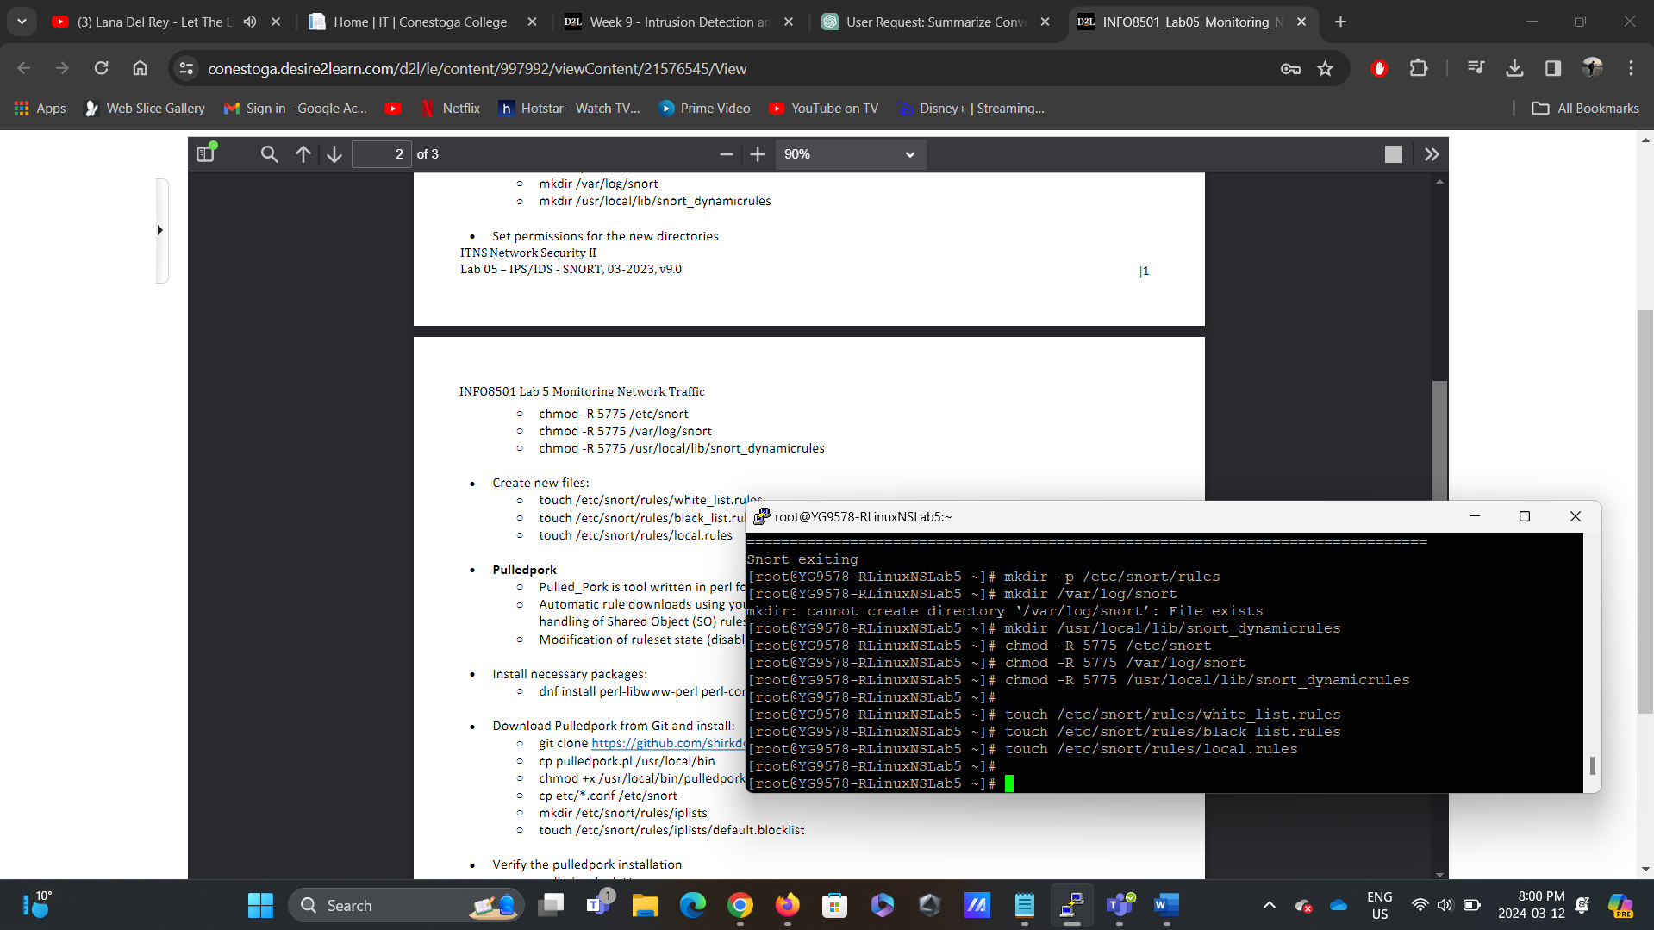

Figure1.6: Terminal Screenshot - Configuring SNORT Directories

In this screenshot, the user creates the required directories for SNORT configuration. Commands such as mkdir -p /etc/snort/rules, mkdir /var/log/snort, and mkdir /usr/local/lib/snort_dynamicrules are executed to create directories for rule sets, log files, and dynamic rules, respectively. And commands like chmod -R 5775 /etc/snort, chmod -R 5775 /var/log/snort, and chmod -R 5775 /usr/local/lib/snort_dynamicrules to grant appropriate permissions. Lastly, Commands such as touch /etc/snort/rules/white_list.rules, touch /etc/snort/rules/black_list.rules, and touch /etc/snort/rules/local.rules are executed to create rule files for white-listing, black-listing, and custom local rules, respectively.

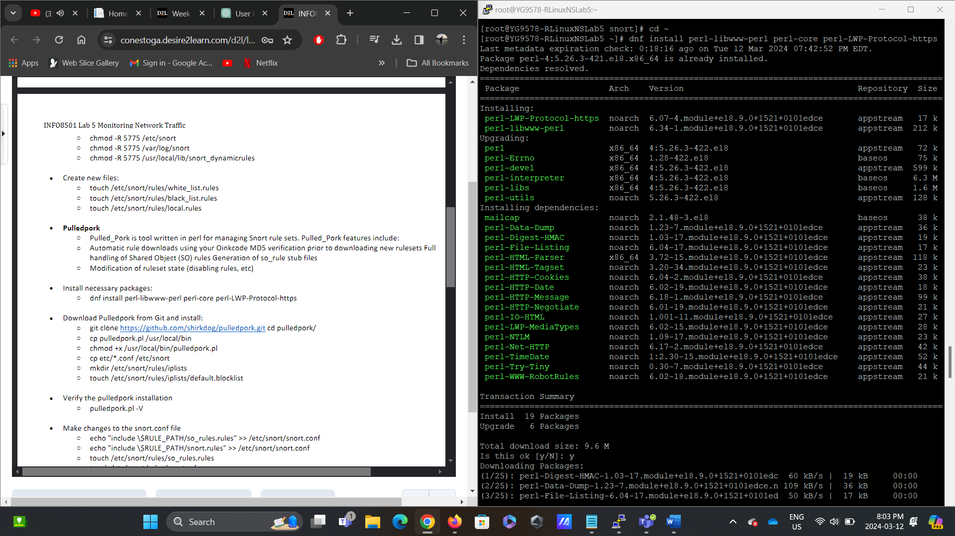

Figure1.7: Terminal Screenshot - Installing PulledPork and Dependencies

This screenshot captures the installation of PulledPork, a tool for managing SNORT rule sets and their dependencies on RockyLinux. The user installs necessary Perl packages using the command dnf install perl-libwww-perl perl-core perl-LWP-Protocol-https and downloads PulledPork from Git.

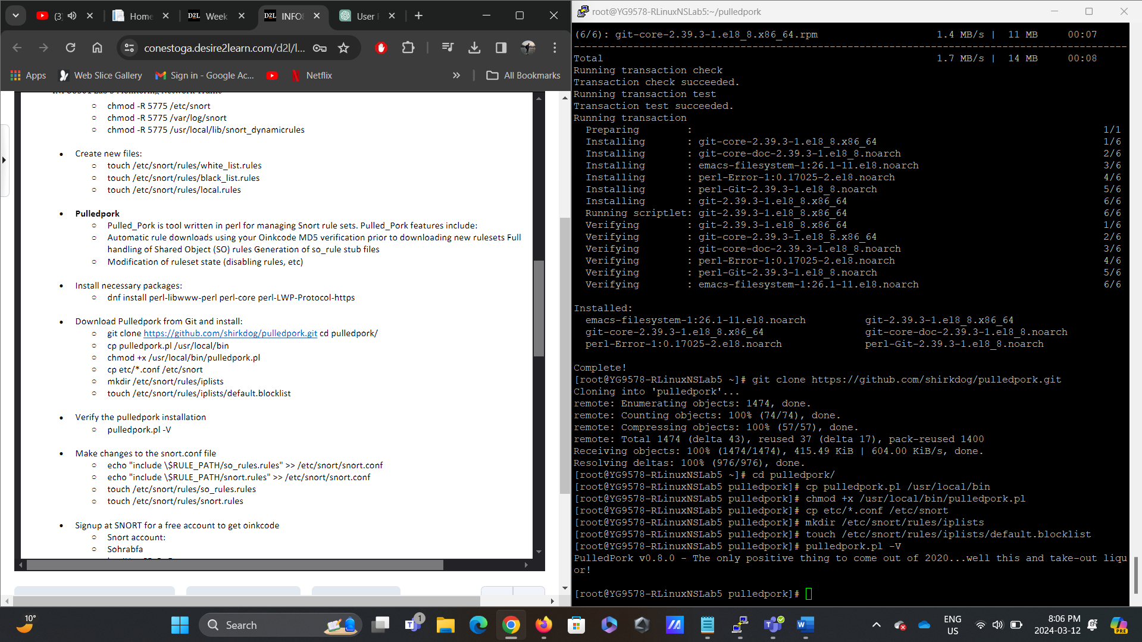

Figure1.8: Terminal Screenshot - Installing PulledPork and Dependencies

This screenshot captures the installation of PulledPork, a tool for managing SNORT rule sets and their dependencies on RockyLinux. The user installs necessary Perl packages using the command dnf install perl-libwww-perl perl-core perl-LWP-Protocol-https and downloads PulledPork from Git.

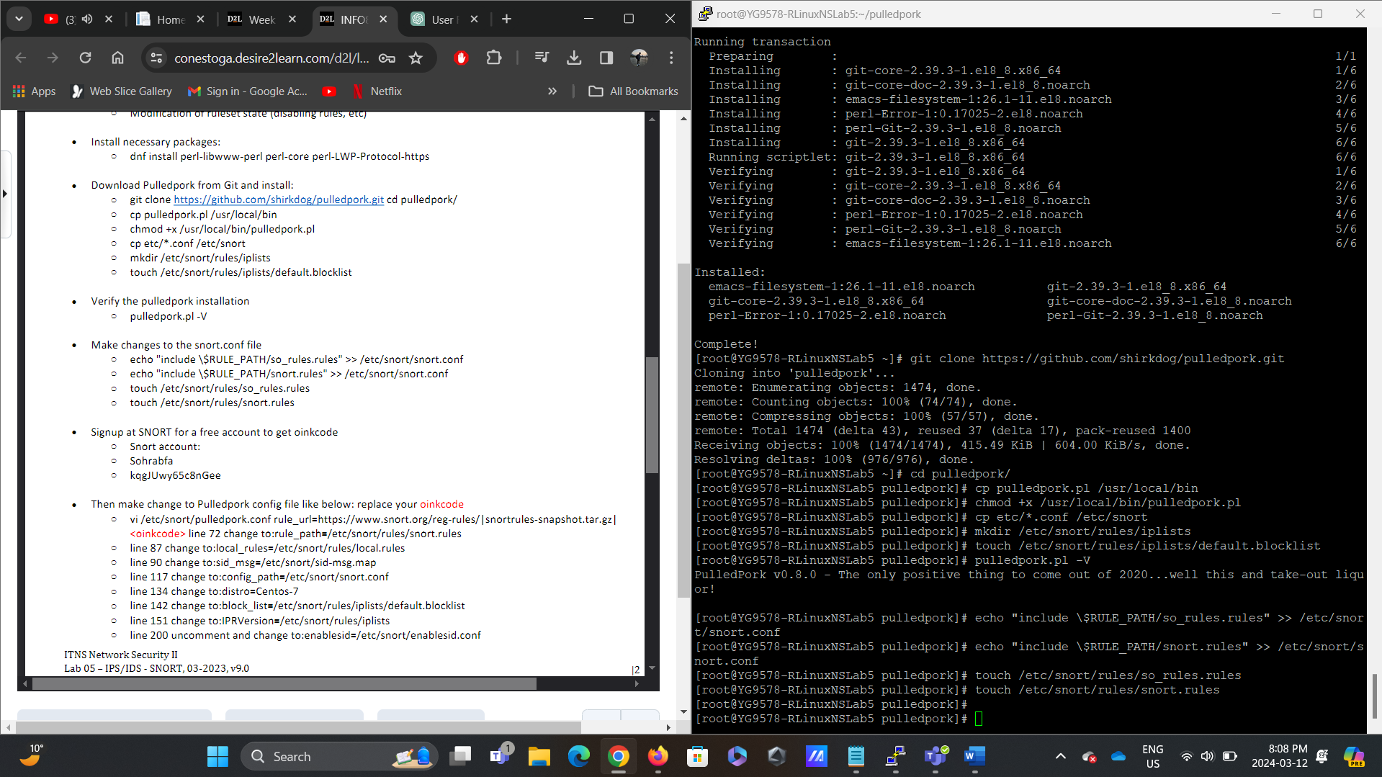

Figure 1.9: Commands such as touch /etc/snort/rules/so_rules.rules, touch /etc/snort/rules/snort.rules are created.

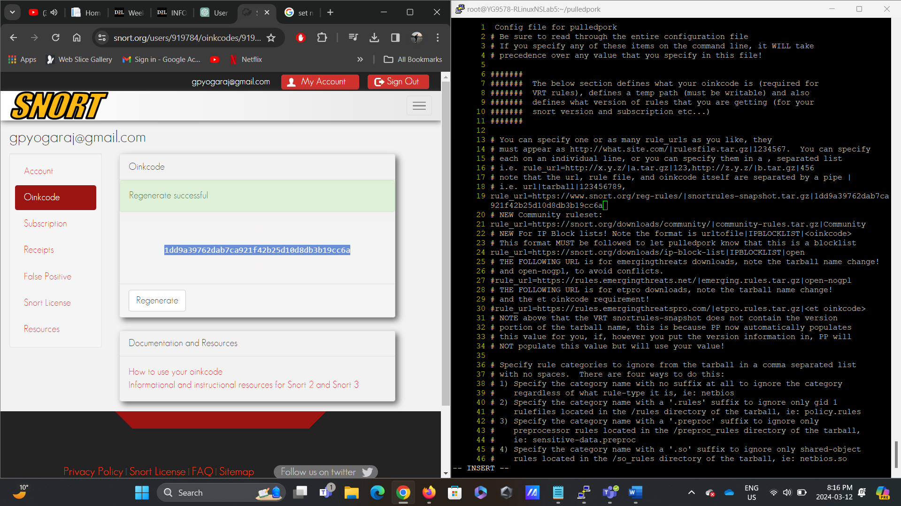

Figure1.10: Terminal Screenshot - Configuring PulledPork

In this screenshot, the user configures PulledPork to work with SNORT. The user changes the PulledPork configuration file (/etc/snort/pulledpork.conf) to specify rule paths, Oinkcode, and other settings required for rule management.

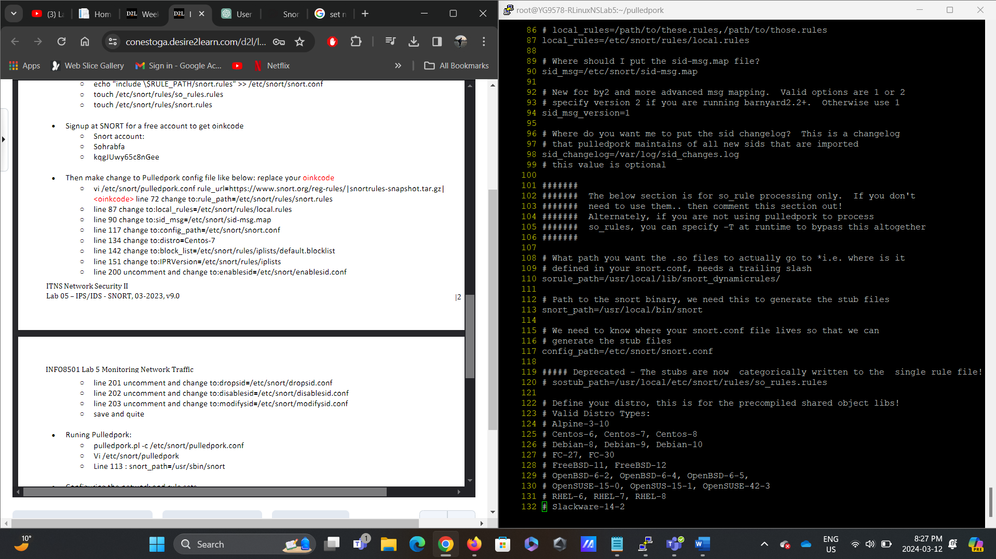

Figure1.11: Terminal Screenshot - Configuring PulledPork

In this screenshot, the user configures PulledPork to work with SNORT. The user changes the PulledPork configuration file (/etc/snort/pulledpork.conf) to specify rule paths, Oinkcode, and other settings required for rule management.

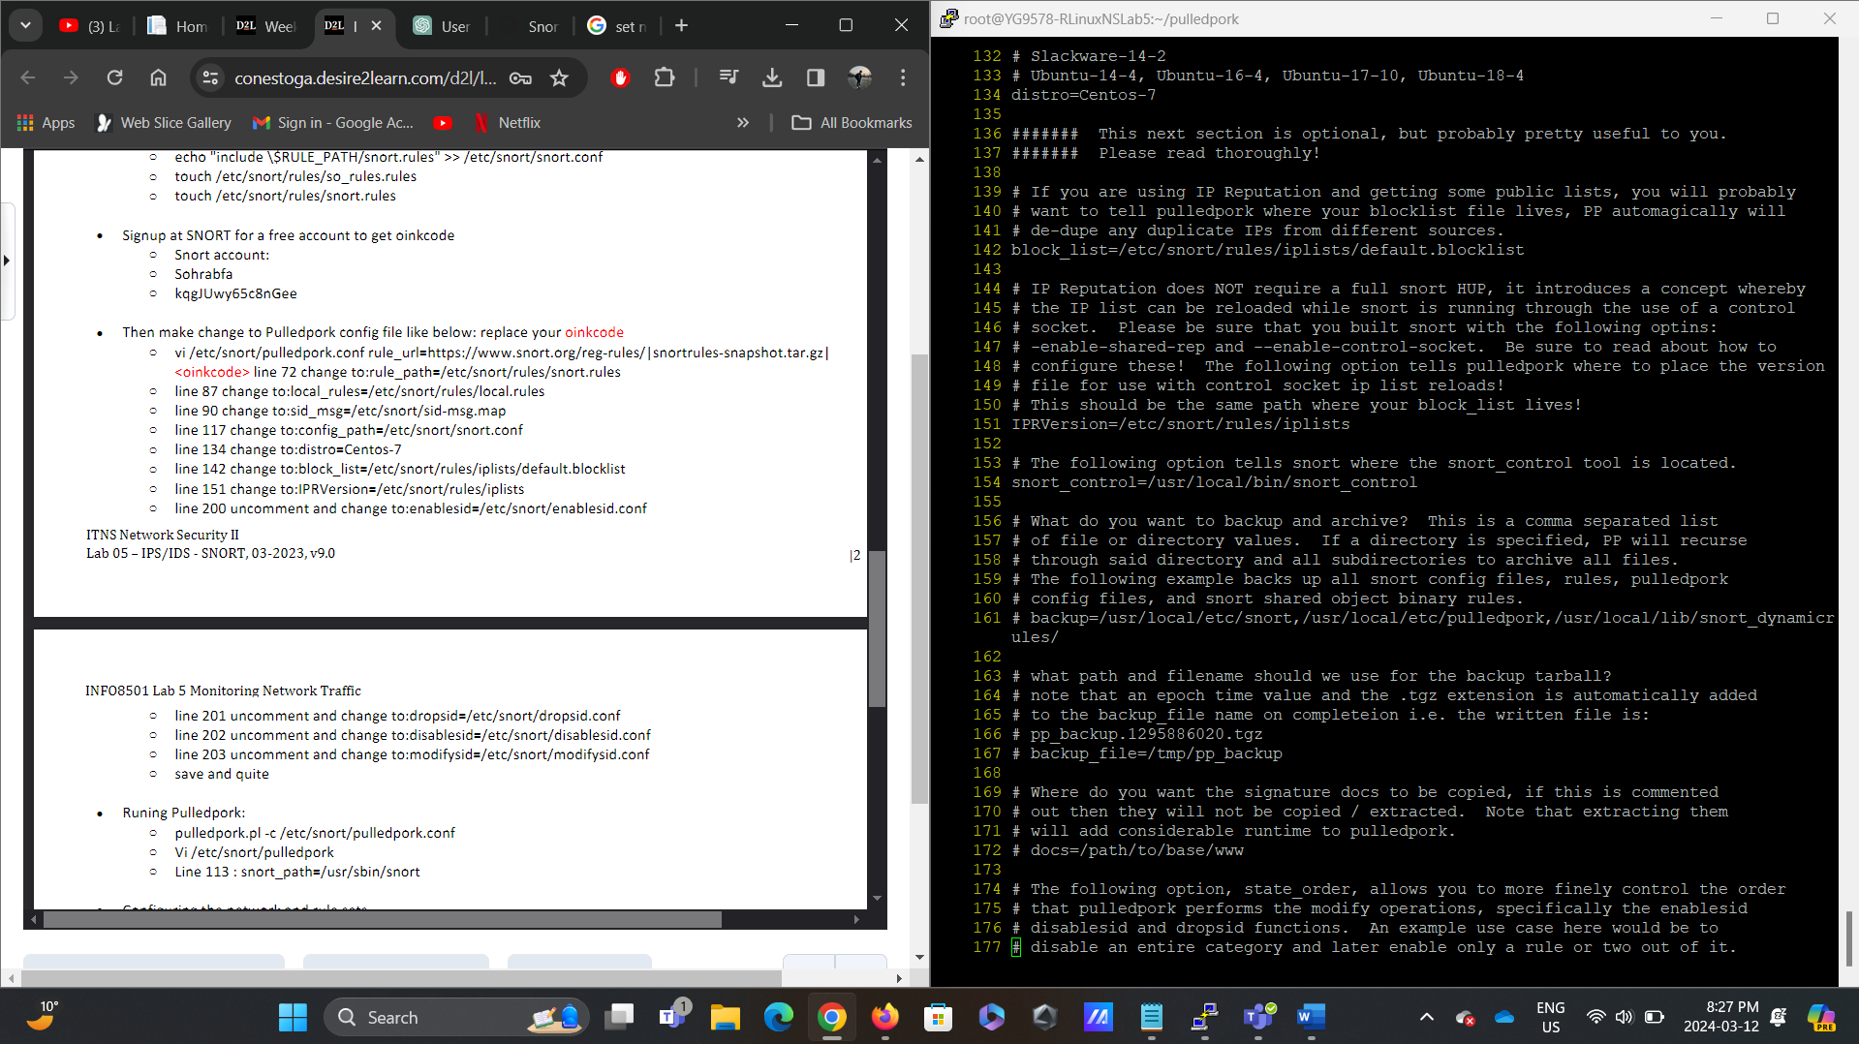

Figure1.12: Terminal Screenshot - Configuring PulledPork

In this screenshot, the user configures PulledPork to work with SNORT. The user changes the PulledPork configuration file (/etc/snort/pulledpork.conf) to specify rule paths, Oinkcode, and other settings required for rule management.

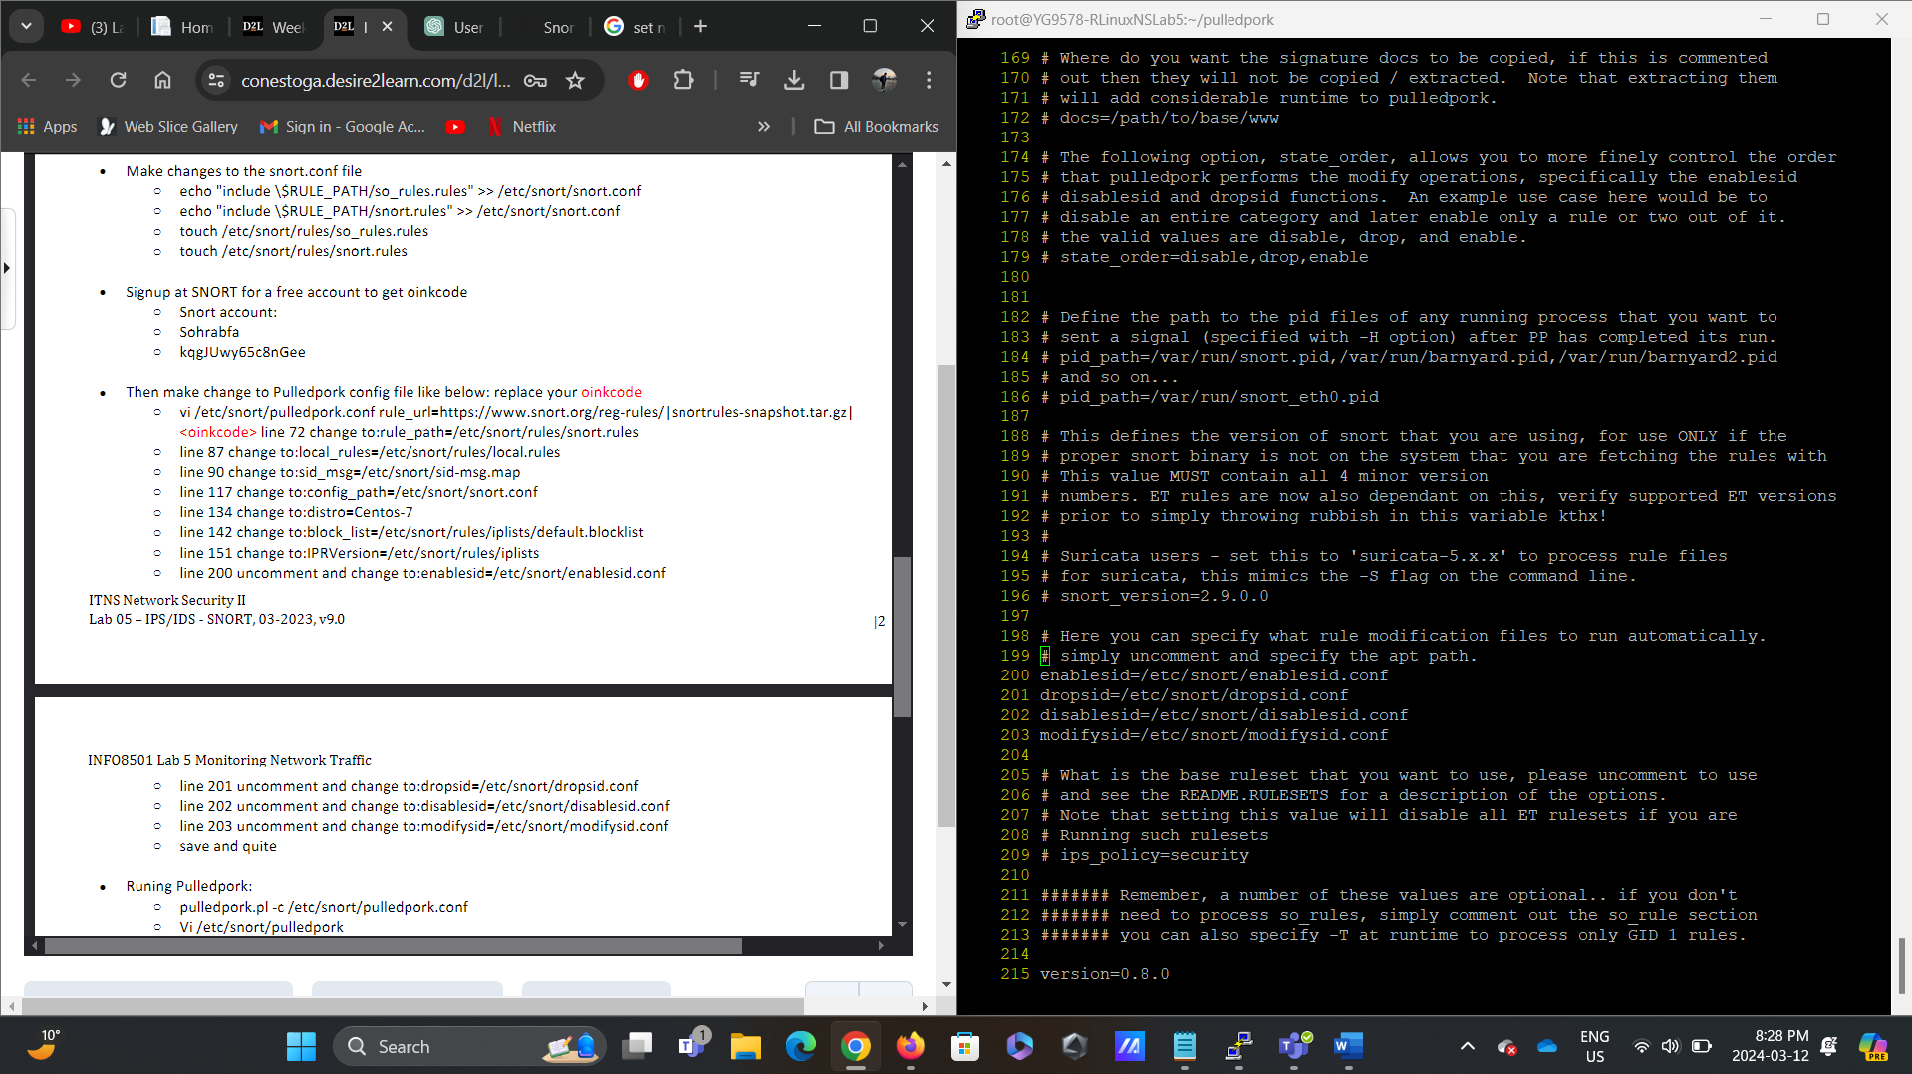

Figure1.13: Terminal Screenshot - Configuring PulledPork

In this screenshot, the user configures PulledPork to work with SNORT. The user changes the PulledPork configuration file (/etc/snort/pulledpork.conf) to specify rule paths, Oinkcode, and other settings required for rule management.

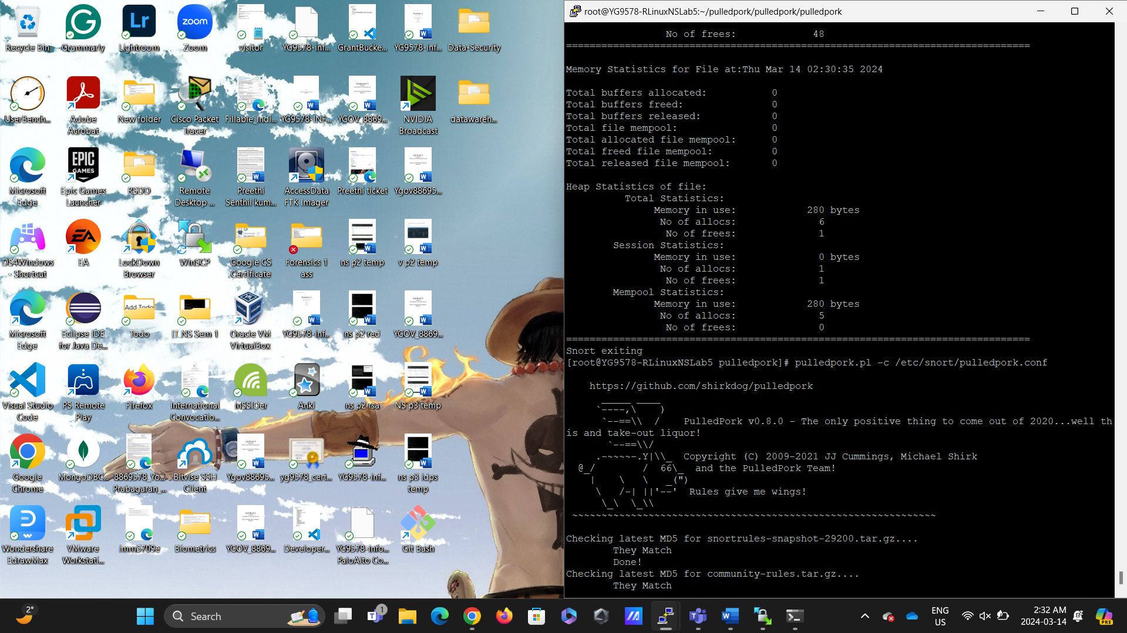

Figure1.14: Terminal Screenshot - Testing Pulledpork Configuration

This screenshot depicts the testing of the Pulledpork configuration using the above command.

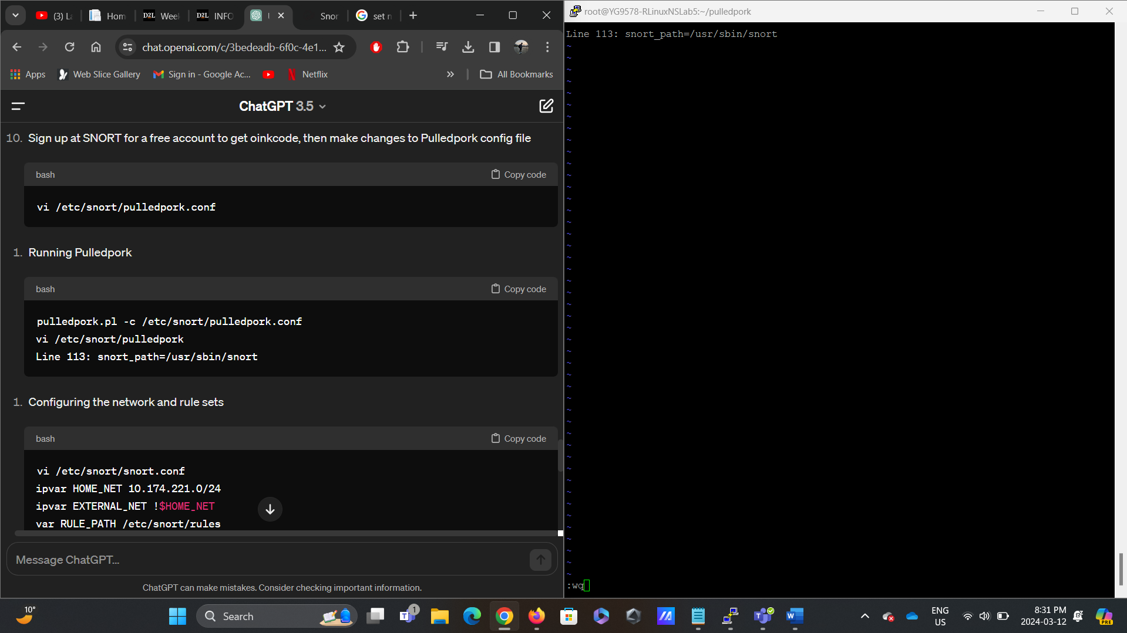

Figure1.15: Terminal Screenshot – Adding the above to /etc/snort/pulledpork

This screenshot depicts the Pulledpork configuration using the above command in the /etc/snort/pulledpork directory using the Vi command.

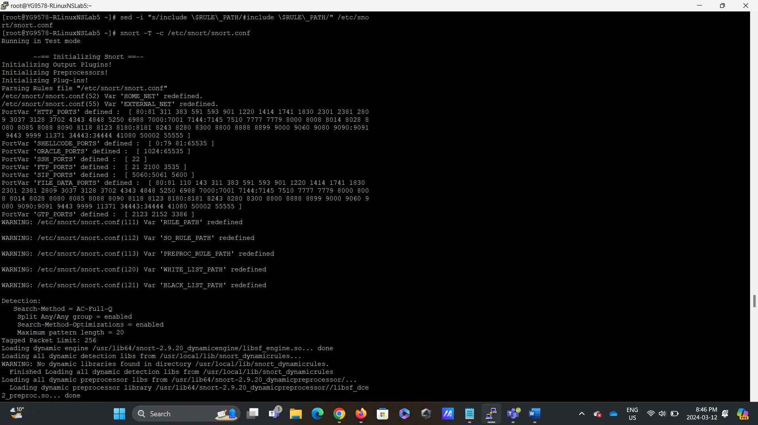

Figure1.18: Terminal Screenshot - Testing SNORT Configuration

This screenshot depicts the testing of SNORT configuration using the command snort -T -c /etc/snort/snort.conf. The user verifies the configuration to ensure SNORT can correctly parse the configuration file and load rule sets without errors.

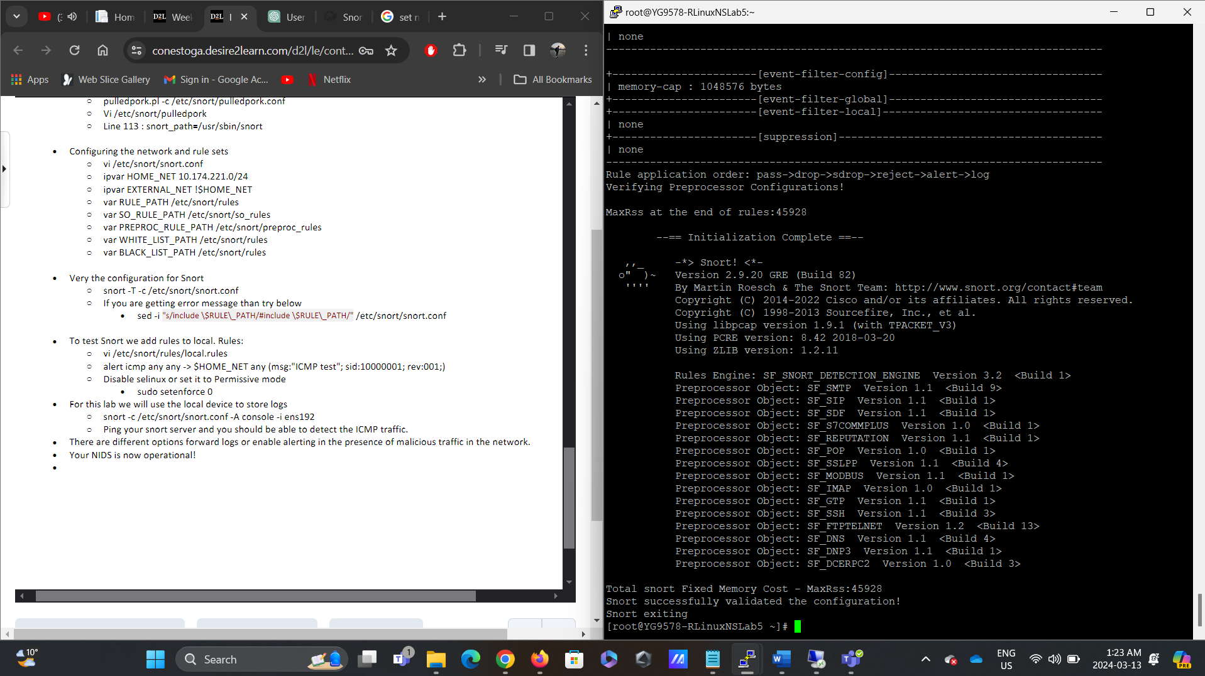

Figure1.19: Terminal Screenshot - Testing SNORT Configuration

This screenshot depicts the testing of SNORT configuration using the command snort -T -c /etc/snort/snort.conf. The user verifies the configuration to ensure SNORT can correctly parse the configuration file and load rule sets without errors.

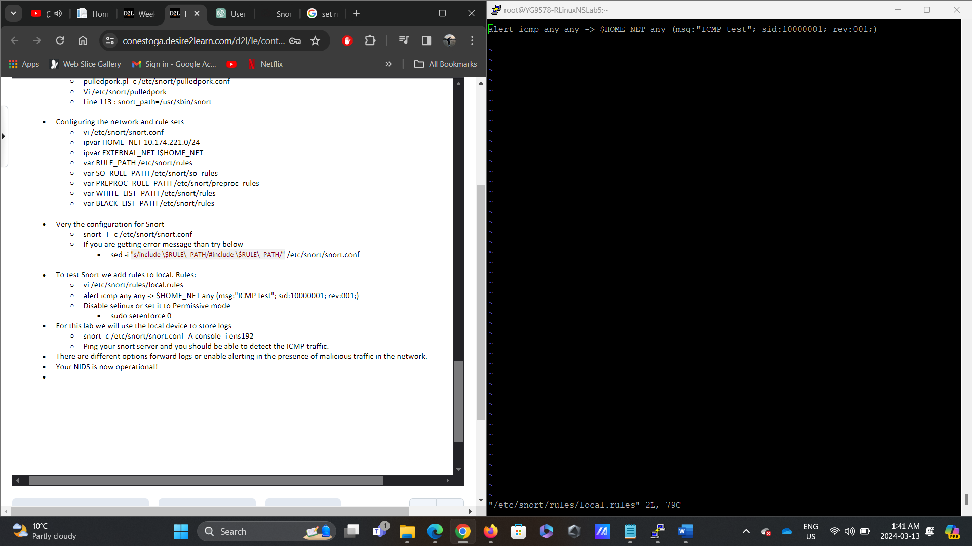

Figure1.20: Terminal Screenshot - Adding Test Rules to SNORT

In this screenshot, the user adds test rules to SNORT for validation. The user edits the local. Rules file (/etc/snort/rules/local.rules) should include a test rule for detecting ICMP traffic. This step helps verify SNORT's functionality in detecting network traffic.

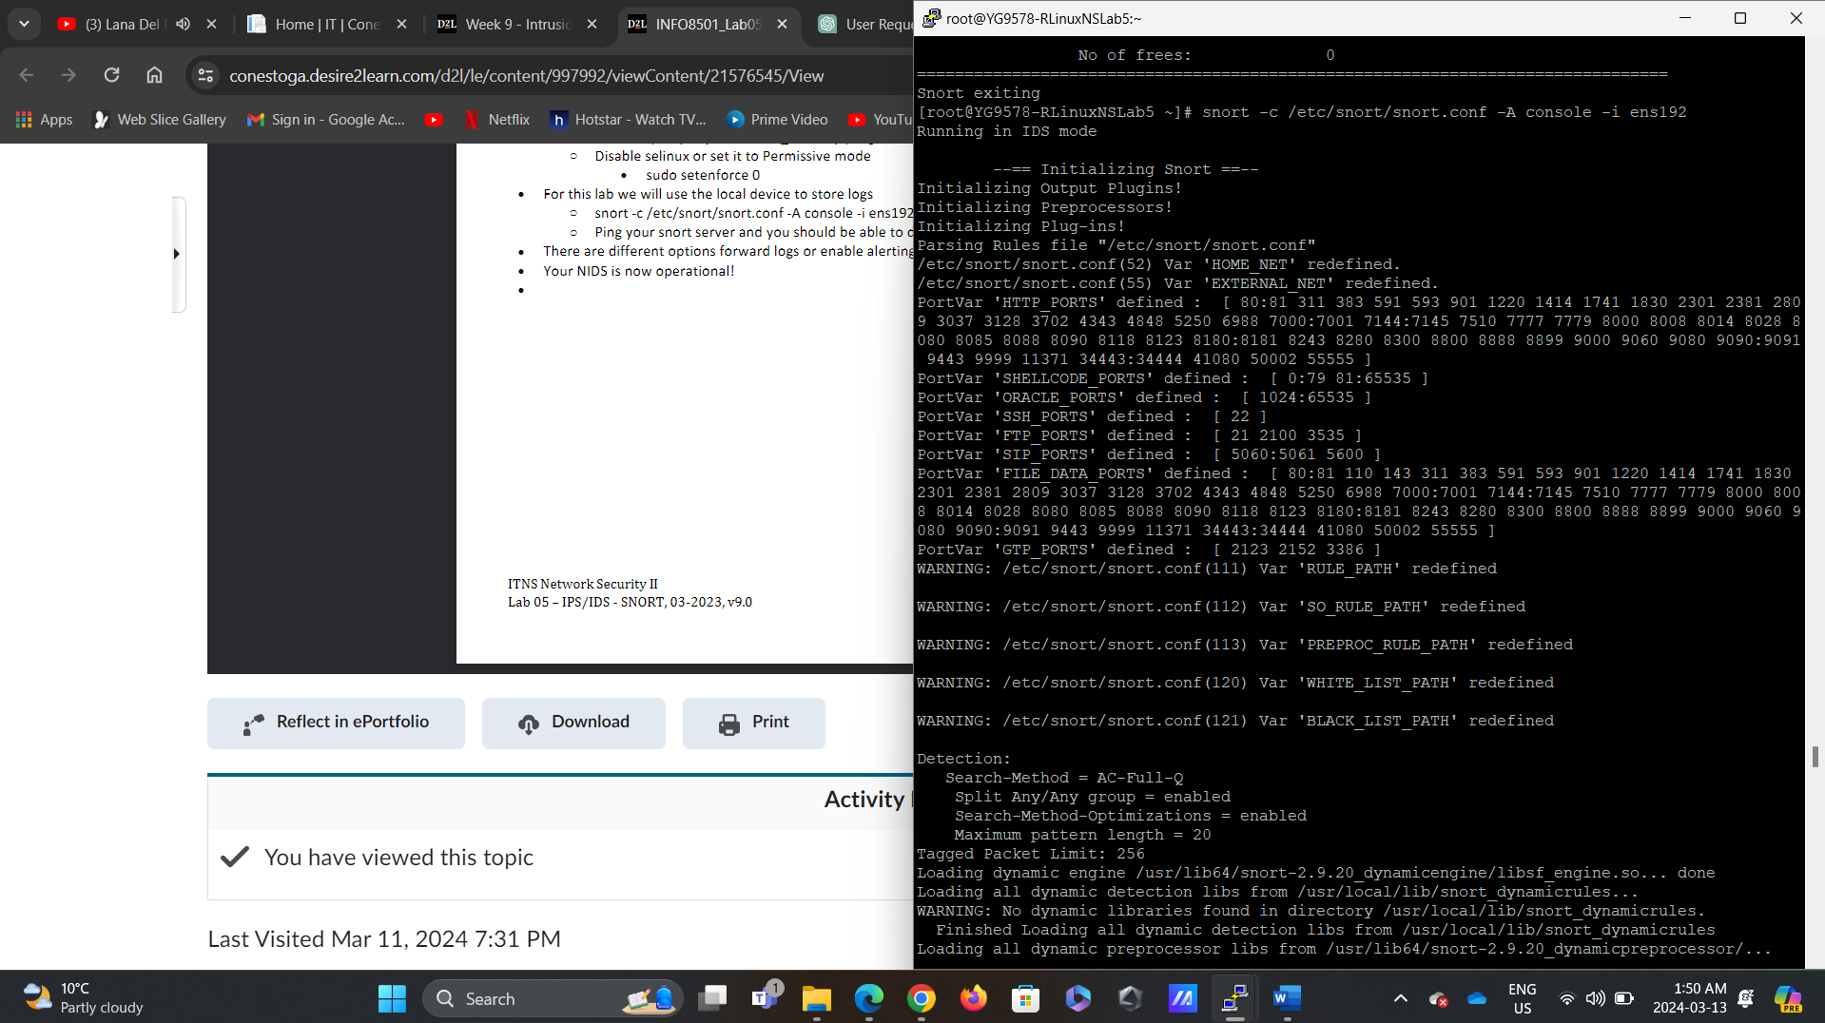

Figure1.21: Terminal Screenshot - Running SNORT

This screenshot captures the execution of SNORT with the configured settings. The user runs SNORT with the command snort -c /etc/snort/snort.conf -A console -i ens192 to start the IDS on the specified network interface (ens192) and monitor network traffic.

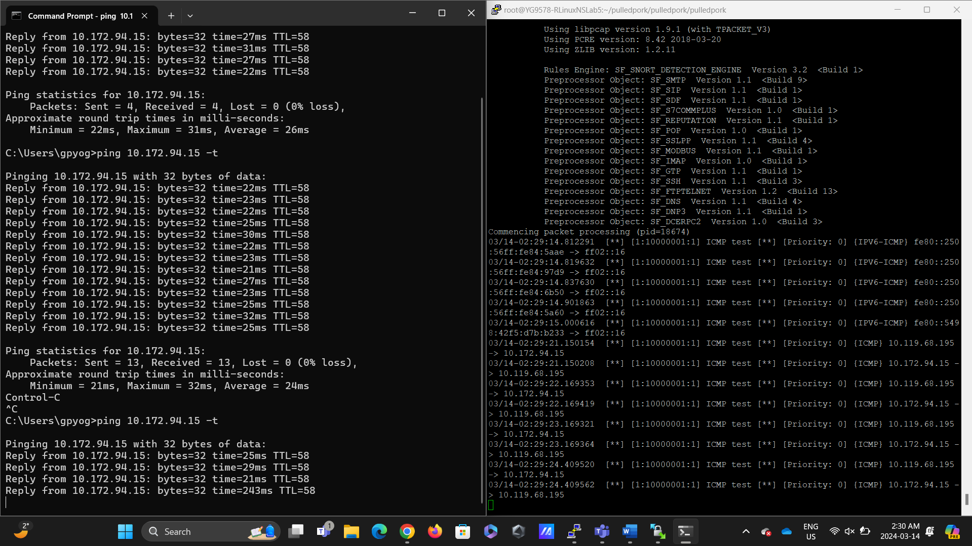

Figure1.22: Terminal Screenshot - Testing SNORT with Ping

The user tests SNORT's functionality in this screenshot by sending ICMP traffic (ping) to the SNORT server. The user verifies that SNORT can detect and log the ICMP traffic, confirming that the NIDS is operational and capable of detecting malicious activity on the network.

## Reflection

Upon completing Part 2 of the lab, it's evident that the configurations successfully enabled SNORT as an active intrusion detection system (IDS). Following the step-by-step instructions, the necessary directories and files were created, and permissions were set appropriately. Additionally, integrating PulledPork facilitated efficient management of SNORT rule sets. The adjustments made to the snort.conf file ensured proper inclusion of rule sets and paths while obtaining the Oinkcode allowed for personalized rule downloads. Overall, these actions led to the successful configuration of SNORT as an operational NIDS. The lab's objectives were achieved, and the NIDS is now ready to monitor and respond to network threats effectively.

# References

1. *libdnet is installed but can’t be found by snort*. (n.d.). Unix & Linux Stack Exchange. <https://unix.stackexchange.com/questions/209813/libdnet-is-installed-but-cant-be-found-by-snort>
2. *Snort: Unable to open rules file*. (n.d.). Server Fault. <https://serverfault.com/questions/660273/snort-unable-to-open-rules-file>
3. *SNORT configuration issue - white_list.rules Error / Newbie Corner / Arch Linux Forums*. (n.d.). <https://bbs.archlinux.org/viewtopic.php?id=225236>
4. *[Snort-users] Warning: I can’t find any whitelist/blacklist entries. Reputation Preprocessor disabled.* (n.d.). Google Groups. <https://groups.google.com/g/mailing.unix.snort/c/RLeiOkPtQik?pli=1>
5. *Snort - Network Intrusion Detection & Prevention System*. (n.d.). <https://www.snort.org/>
6. *Snort - Error while running*. (n.d.). Stack Overflow. <https://stackoverflow.com/questions/22608833/snort-error-while-running>
7. *PulledPork can’t locate the Snort binary*. (n.d.). Stack Overflow. <https://stackoverflow.com/questions/31096920/pulledpork-cant-locate-snort-binary>
8. R. (2022, July 7). *Installing and Configuring SNORT IDS/IPS in Centos8*. YouTube. <https://www.youtube.com/watch?v=Cxlm6Iqw7j8>
9. Ruostemaa, J. (2023, May 24). *How to install Snort on CentOS &#x2d; UpCloud*. UpCloud. <https://upcloud.com/resources/tutorials/installing-snort-on-centos>
10. N. (2021, November 1). *Rocky Linux8.4 ; Tripwire, Chkrootkit and Snort installed*. Linux Server Construction. <https://korodes.com/en/rocky_04-2/>
11. *GlobalProtect*. (n.d.). <https://s3.amazonaws.com/assets.paloaltonetworksacademy.net/elearning/EDU-110-MOD11/story_html5.html>

# 